|  |  |
| --- | --- |
| This is an open access article published under a [Creative](http://pubs.acs.org/page/policy/authorchoice_ccbyncnd_termsofuse.html) Commons Non-Commercial No Derivative Works (CC-BY-NC-ND) Attribution [License](http://pubs.acs.org/page/policy/authorchoice_ccbyncnd_termsofuse.html), which permits copying and redistribution of the article, and creation of adaptations, all for non-commercial purposes. |  |

Research Article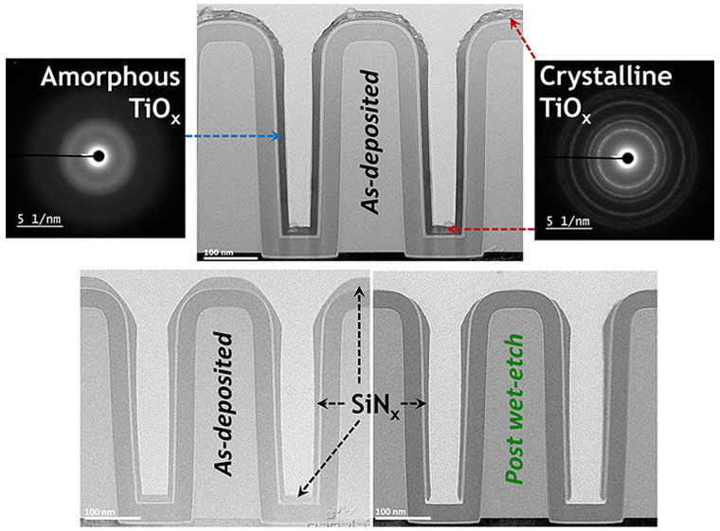

Cite This: [ACS Appl. Mater. Interfaces XXXX, XXX, XXX−XXX](http://pubs.acs.org/action/showCitFormats?doi=10.1021/acsami.8b00183)  www.acsami.org

Tuning Material Properties of Oxides and Nitrides by Substrate Biasing during Plasma-Enhanced Atomic Layer Deposition on Planar and 3D Substrate Topographies

Tahsin Faraz,*,†Harm C. M. Knoops,†,#Marcel A. Verheijen,†,‡Cristian A. A. van Helvoirt,†Saurabh Karwal,†Akhil Sharma,†Vivek Beladiya,⊥Adriana Szeghalmi,⊥,∞Dennis M. Hausmann,§Jon Henri,§Mariadriana Creatore,†and Wilhelmus M. M. Kessels*,†

†Eindhoven University of Technology, P.O. Box 513, 5600 MB Eindhoven, The Netherlands   
#Oxford Instruments Plasma Technology, North End, Bristol, BS49 4AP, United Kingdom  
‡Philips Innovation Services, High Tech Campus 4, 5656 AE Eindhoven, The Netherlands  
⊥Friedrich Schiller University Jena, Albert-Einstein-Str. 13, 07745 Jena, Germany  
∞Fraunhofer Institute for Applied Optics and Precision Engineering IOF, Albert-Einstein-Str. 7, 07745 Jena, Germany§Lam Research Corporation, 11155 SW Leveton Drive, Tualatin, Oregon 97062, United States

|  |
| --- |
| * S Supporting Information |

|  |
| --- |
| ABSTRACT: Oxide and nitride thin-films of Ti, Hf, and Si serve numerous  applications owing to the diverse range of their material properties. It is  therefore imperative to have proper control over these properties during  materials processing. Ion-surface interactions during plasma processing  techniques can influence the properties of a growing film. In this work, we  investigated the effects of controlling ion characteristics (energy, dose) on the  properties of the aforementioned materials during plasma-enhanced atomic  layer deposition (PEALD) on planar and 3D substrate topographies. We used  a 200 mm remote PEALD system equipped with substrate biasing to control  the energy and dose of ions by varying the magnitude and duration of the  applied bias, respectively, during plasma exposure. Implementing substrate  biasing in these forms enhanced PEALD process capability by providing two  additional parameters for tuning a wide range of material properties. Below  the regimes of ion-induced degradation, enhancing ion energies with substrate biasing during PEALD increased the refractive index and mass density of TiOx and HfOx and enabled control over their crystalline properties. PEALD of these oxides with substrate biasing at 150 °C led to the formation of crystalline material at the low temperature, which would otherwise yield amorphous films for deposition without biasing. Enhanced ion energies drastically reduced the resistivity of conductive TiNx and HfNx films. Furthermore, biasing during PEALD enabled the residual stress of these materials to be altered from tensile to compressive. The properties of SiOx were slightly improved whereas those of SiNx were degraded as a function of substrate biasing. PEALD on 3D trench nanostructures with biasing induced differing film properties at different regions of the 3D substrate. On the basis of the results presented herein, prospects afforded by the implementation of this technique during PEALD, such as enabling new routes for topographically selective deposition on 3D substrates, are discussed. |

|  |  |
| --- | --- |
| KEYWORDS: atomic layer deposition, plasma ALD, thin film, ion energy control, substrate biasing, ion bombardment, tuning material properties, oxides, nitrides, SiO2, SiNx, TiO2, TiN, HfO2, HfNx | |
| ■INTRODUCTION  The ubiquity of thin-films in emerging nanotechnology applications,1together with device scaling using 3-dimensional | exposures lead to excellent film uniformity on large area substrates and unparalleled conformality on high-aspect-ratio 3D nanostructures. In conventional thermal ALD, the energy |
| (3D) architectures,2,3place stringent requirements on nanoscale | needed for surface reactions to proceed is provided by substrate |
| processing techniques used in thin-film deposition. Atomic layer | heating. An alternate source for the required energy can be |

deposition (ALD) is a well-known method for obtaining ultrathin films with precise growth control.4It is a cyclic

|  |
| --- |
| obtained by using an energy enhanced ALD method known as |

|  |  |  |  |  |  |
| --- | --- | --- | --- | --- | --- |
| deposition process based on sequential and self-limiting reactant | | A | Received: | January 4, 2018 | DOI: [10.1021/acsami.8b00183](http://dx.doi.org/10.1021/acsami.8b00183) ACS Appl. Mater. Interfa[ces XXXX, XXX, XXX−XXX](http://dx.doi.org/10.1021/acsami.8b00183) |
| dose steps for synthesizing thin-films in a layer-by-layer manner. | |
| Accepted: | March 19, 2018 |
| The self-limiting surface reactions during the separate reactant | | Published: March 19, 2018 | |
|  | © XXXX American Chemical Society |

|  |  |  |
| --- | --- | --- |
| ACS Applied Materials & Interfaces | |  | | --- | | Research Article | |

plasma-enhanced atomic layer deposition (PEALD).5In PEALD, the substrate is exposed to species generated by a plasma during one of the reactant exposure steps of an ALD cycle.5,6These species constitute a mixture of highly reactive atomic and molecular neutrals (plasma radicals), photons, ions and electrons. The highly reactive plasma species generated during PEALD can provide an alternate source of the energy required for film growth. The high reactivity of the plasma species therefore, allows access to a parameter space such as low temperature deposition environments. Tuning material proper-ties during film growth at a particular temperature is typically performed by varying either the substrate material or the reactants needed for film deposition. For PEALD at any given temperature, the various parameters of plasma operating conditions (e.g., reactant gas, flow rate, pressure, power, direct/remote source configuration, etc.) allow greater freedom in processing conditions for tuning the growth and material properties of thin-films.6   
 Apart from the contribution of highly reactive plasma radicals toward film growth during PEALD, the ions generated by the plasma can also play a significant role during film deposition.5,6 Ion-surface interactions during plasma exposure are a character-istic feature of plasma-enhanced deposition techniques.7−10 Additional energy can be provided to the deposition surface by the kinetic energy of ions impinging on the substrate. While plasma radicals can enable film growth through their high reactivity, the additional energy delivered to the deposition surface by ion bombardment can influence a wide range of material properties of the growing film. Examples reported in the literature include tailoring of the optical refractive index, electrical conductivity, mechanical stress, mass density, crystal-line structure, morphology, surface roughness etc.9,11,12The limit to which ion-surface interactions can modify such properties depends on the energy, mass, reactivity, impingement rate (or flux) and dose (or net flux integrated over time) of ionic species impinging on the film surface.7−9,13,14On the basis of the values of these parameters, various physical, chemical or combined physicochemical processes can occur at the surface and subsurface regions of the film as the ions transfer energy and momentum during deposition. The use of an inert gas (e.g., argon) leads to predominantly physical processes which include, but are not limited to, surface or bulk atom displacements, subsurface implantation of incident ions or displaced surface atoms, desorption of adsorbed surface impurities from reactor background, etc.8,9,14The use of reactive gases (e.g., oxygen or hydrogen) involves an additional chemical or physicochemical component where the reactive ions can undergo chemical reactions forming, either stable products leading to film growth, or volatile products leading to film removal.8,10However, the processes and trends of property modulation also depend on many inherent characteristics of the growing film such as the bond energy, bond type (i.e., ionic, covalent or metallic), crystallization temperature, free energy difference between crystalline and amorphous phases or a combination of several of these parameters.14−17Given the multitude of factors that can play a role during ion-surface interactions, it is not a trivial or straightforward task to anticipate the trends in film characteristics as a result of varying the ion characteristics during deposition. Furthermore, the effects of ion-surface interactions have been extensively investigated in the literature for conventional flux-controlled processes,18such as physical vapor deposition (PVD) and plasma-enhanced chemical vapor deposition (PECVD), that lead to continuous film growth. In the surface-controlled

B DOI: [10.1021/acsami.8b00183](http://dx.doi.org/10.1021/acsami.8b00183)

|  |  |  |
| --- | --- | --- |
| ACS Applied Materials & Interfaces | |  | | --- | | Research Article | |

dielectric or conductive materials that are used in a variety of applications (see [Supporting Information](http://pubs.acs.org/doi/suppl/10.1021/acsami.8b00183/suppl_file/am8b00183_si_001.pdf)). The diverse range of applications that are heavily reliant on the properties of these materials highlights the necessity for precise control over those properties during film deposition. Enhancing ion energies with substrate biasing during PEALD on planar substrates was observed to have pronounced effects on the growth and material properties of the aforementioned thin-films. A comprehensive analysis of these properties was undertaken by characterizing the growth rate, mass density, refractive index (for dielectric materials), resistivity (for conductive materials), residual stress, and surface roughness of the films deposited on planar substrates. The role of ion energy control on film microstructure and crystallinity was also investigated. The effect of enhanced ion energies on the thickness uniformity of materials deposited on large area planar substrates (200 mm Si wafer) was also investigated compared to previous work carried out on smaller substrates.19,20Owing to the material and/or process specific effects of substrate biasing observed in previous work, an empirical investigation comprised of an extensive character-ization of film properties spanning six different materials was undertaken in this work. It was observed that substrate biasing can enhance the versatility of PEALD processes by providing two additional parameters (magnitude, duration/duty cycle of bias) for tuning a wide range of material properties. Furthermore, biasing during PEALD on 3D trench nanostructures effectively delineated the role of directional ion bombardment by inducing differing film properties at different (planar and vertical) regions of the 3D substrate. These results demonstrate the potential of substrate biasing during PEALD in enabling routes toward topographically selective3processing on 3D substrates.

■APPLYING SUBSTRATE BIAS DURING PEALD CYCLES

In a remote plasma ALD reactor configuration, the plasma source generating radicals and ions is located at a distance away from the substrate stage thus allowing the plasma and substrate conditions to be varied quite independently of each other. The ion flux impinging on the substrate can be increased by increasing the source power. When the substrate is exposed to the plasma, a positive space charge layer called the sheath is formed between the plasma and the substrate due to the difference in mobilities of the heavy ions and light electrons in the plasma. The voltage across the sheath (ΔVsheath) is the difference between the plasma potential (Vp) and the substrate potential (Vsub). The sheath voltage repels electrons from the substrate into the plasma and accelerates ions toward the substrate resulting in so-called ion bombardment. At sufficiently low pressures, the ion mean free path is larger than the plasma sheath thickness, so the ions are accelerated over the full sheath width without undergoing collisions. This collisionless plasma sheath condition leads to the highly directional or anisotropic nature of ion bombardment. Typical sheath thicknesses for processing plasmas are on the order of 10−4−10−2m, and therefore, the sheath does not follow the profile of 3D structures (e.g., trenches and vias) with micro-or nanoscale dimensions. As a result, directional ions accelerated through a collisionless sheath will mainly collide with substrate surfaces parallel to the sheath, for example, the planar top and bottom surfaces of a 3D trench nanostructure and not its vertical sidewalls. The energy (Ei) of directional ions impinging on planar substrate surfaces is proportional to the sheath voltage, as shown in equation 1

C DOI: [10.1021/acsami.8b00183](http://dx.doi.org/10.1021/acsami.8b00183)

|  |  |  |
| --- | --- | --- |
| ACS Applied Materials & Interfaces | |  | | --- | | Research Article | |

Table 1. PEALD Process Conditions for the Materials Deposited with and without Substrate Biasing during Plasma Exposure

|  |  |  |  |  |  |  |
| --- | --- | --- | --- | --- | --- | --- |
| material | TiOx | TiNx | HfOx | HfNx | SiOx | SiNx |
| precursor | TDMATa | | TDMACpHb | | BDEASc | DSBASd |
| bubbler temperature (°C) | 60 | | 60 | | 50 | 40 |
| precursor delivery | bubbled with 100 sccm Ar | | bubbled with 100 sccm Ar | | vapor drawn | |
| stage temperature (°C) | 150 and 300 | 200 | 150 | 450 | 200 | 500 |
| precursor dose time (ms) | 200 | 200 | 400 | 400 | 175 | 500 |
| precursor reaction step (s) | 3 | 3 | 2 | 2 | 1 | 3 |
| precursor purge time (s) | 3 | 2 |
| plasma gas | O2 | Ar + H2 | O2 | H2 | O2 | N2 |
| plasma gas flow (sccm) | 100 | 10 + 40 | 100 | 100 | 100 | 100 |
| plasma pressure (mTorr) | 9 | 6 | 15 | 30 | 15 | 11 |
| RF-ICP power (W) | 200 | 100 | 400 | 100 | 200 | 600 |
| plasma exposure time (s) | 10 | 10 | 8 | 10 | 5 | 20 |
| plasma purge time (s) | 3 | 4 | 3 | 4 | 2 | 3 |
| ⟨Vbias⟩ or average bias voltage (V) | 0 to −254 | 0 to −255 | 0 to −280 | 0 to −210 | 0 to −295 | 0 to −103 |
| bias during plasma | all 10 s, last 5 s | last 5 s | last 4 s | all 10 s, last 5 s | all 5 s | last 10 s |

aTDMAT − Ti(NMe2)4. bTDMACpH − CpHf(NMe2)3. cBDEAS − SiH2(NEt2)2. dDSBAS − SiH3N(sBu)2.

applying it in an interleaved manner either at the beginning, middle or end (Figure 1c) of the plasma exposure step. Varying the duration of the applied bias translates to changing the dose or fluence13,14,21(i.e., particle flux integrated over time) of higher energy ions impinging on the substrate. Substrate biasing during PEALD can also be implemented in many other configurations (see [Figures S1 and S2](http://pubs.acs.org/doi/suppl/10.1021/acsami.8b00183/suppl_file/am8b00183_si_001.pdf)).

■EXPERIMENTAL DETAILS   
 PEALD Process Conditions. Film deposition using PEALD was performed in an Oxford Instruments FlexAL reactor equipped with substrate biasing (Figure 2). The reactor consists of a radio frequency (RF) power supply (13.56 MHz, up to 600 W) connected to a water-cooled copper coil wrapped around a cylindrical alumina tube to generate an inductively coupled-plasma (ICP). This remote RF-ICP source generates the radicals and ions during the plasma exposure step of PEALD. For the specific FlexAL configuration, an additional external RF power supply (13.56 MHz, up to 100 W) can be connected to the reactor table that allows for substrate biasing (up to ⟨Vbias⟩ ≈ −350 V at∼10 mTorr) during plasma exposure. Both RF power sources were connected to the system via automated matching networks consisting of inductive and capacitive components. The FlexAL system provides a readout for ⟨Vbias⟩ when applying an RF bias signal during plasma exposure. Additionally, an oscilloscope was connected to the reactor table via a high-voltage probe from which sinusoidal RF bias voltage waveforms developing on the table could be measured. These oscilloscope measurements were used to independently verify ⟨Vbias⟩readouts from the FlexAL system (within ±5 V). A base pressure in the reactor chamber of ∼10−6Torr was obtained using a turbo pump. A butterfly valve in front of the turbo pump controlled the effective pumping speed and functioned as an automated pressure controller. The chamber wall temperature was set to 150 °C while the substrate stage temperature was set between 150 and 500 °C. All substrates underwent a 30 min heating step prior to commencing deposition in order to ensure substrate temperature stabilization. The precursor delivery lines were heated to 70 °C to prevent precursor condensation. The oxides and nitrides of Ti, Hf, and Si were deposited without and with substrate biasing. The precursors, plasma gases and other PEALD process conditions for depositing the six materials are shown in Table 1. Existing PEALD processes for these six materials22−28were used for the runs without any biasing where the substrate table was grounded during the plasma exposure step. For the runs performed with substrate biasing, the PEALD processes were modified by applying an RF bias signal to the substrate table during the plasma exposure step. PEALD step sequences without (Figure 1a) and with substrate biasing (Figure 1b and c) were implemented. Details regarding PEALD process conditions are further outlined in the [Supporting Information](http://pubs.acs.org/doi/suppl/10.1021/acsami.8b00183/suppl_file/am8b00183_si_001.pdf).

D DOI: [10.1021/acsami.8b00183](http://dx.doi.org/10.1021/acsami.8b00183)

|  |  |  |
| --- | --- | --- |
| ACS Applied Materials & Interfaces | |  | | --- | | Research Article | |

biasing where the deposited layer was parametrized using two Tauc−Lorentz oscillators.19,29For TiNx and HfNx, different models were used for the films deposited with and without biasing. The optical model used for the films grown without biasing consisted of a silicon substrate, ∼450 nm thermal oxide and the deposited layer parametrized using one Drude, one Lorentz, and one Tauc−Lorentz oscillator.26The TiNx and HfNx films deposited with biasing were parametrized using one Drude and two Lorentz oscillators.29   
 The root-mean-squared (RMS) surface roughness and mass density of the films deposited on planar substrates were analyzed using X-ray reflectometry (XRR) performed using a Bruker AXS D8 Advance system in the grazing incidence geometry with a Cu Kα X-ray source (radiation wavelength of 0.154 nm).30The thicknesses of the deposited films were also obtained with XRR which were in good agreement with the corresponding values obtained using SE. The residual stress levels of the deposited films were determined by means of wafer-curvature measurements at room temperature. A KLA-Tencor FLX 2320 system was used to determine the curvature of 3 in. double side polished (DSP) c-Si (100) wafers before and after deposition of the films. Based on the difference in curvature, the residual stress of the films deposited with and without substrate biasing was calculated using the Stoney equation.19,30 A sign convention was used where positive values represented tensile and negative values represented compressive residual stress. Rutherford backscattering spectrometry (RBS) and elastic recoil detection (ERD) measurements were used to determine the composition (stoichiometry) of films deposited on planar SSP c-Si substrates with ∼1.5 nm native oxide. The RBS and ERD measurements with subsequent data simulations were performed by the company Detect 99 using a 1.8−2 MeV helium-ion beam. The areal densities of the elements were determined from raw data simulations. The crystallinity of films deposited on planar c-Si substrates was analyzed using grazing incidence X-ray diffraction (XRD). The measurements were performed in a PANalytical X’pert PRO MRD with a Cu Kα X-ray source (radiation wavelength of 0.154 nm) operated at an incidence angle of 0.5°. A JEOL ARM 200 transmission electron microscope (TEM) operated at 200 kV was used to analyze the microstructure of films deposited on planar TEM windows. These windows consisted of ∼15 nm Si3N4 membranes coated with 5 nm of SiO2 grown using ALD. This ensured a SiO2 starting surface while maintaining transparency to the electron beam. Both bright-field TEM (BF-TEM) and high-angle-annular-dark-field scan-ning TEM (HAADF-STEM) modes were employed to characterize the samples in plan-view. Electrical sheet resistance measurements of conductive films deposited on c-Si substrates with ∼450 nm thermal oxide were performed at room temperature using a Signatone four-point probe (FPP) in combination with a Keithley 2400 Source Measurement Unit (SMU) that acted as both current source and voltage meter. The electrical resistivity was obtained from the slope of the generated I−V curve and the film thickness deduced from the SE measurements. For investigating material properties on 3D substrate topographies, films were deposited with and without substrate biasing during PEALD on coupons containing high aspect ratio trench nanostructures (width∼100 nm, height ∼450 nm, AR = 4.5:1) and analyzed with cross-sectional TEM. These 3D nanostructures were created28by first depositing a thick SiO2 film on a Si wafer using PECVD, that was subsequently etched into trench structures. The SiO2 trench structures were then coated with a SiNx layer using high-temperature CVD, on which a SiO2 layer was deposited using ALD. Coupons containing these trench nanostructures were prepared and provided by Lam Research. A JEOL 2010F ultrahigh-resolution scanning TEM at 200 kV (Nanolab Technologies) was employed to obtain cross-sectional images of the films deposited on the 3D trench nanostructures. The films were coated with a layer of spin-on epoxy to protect them from damage during sample preparation for TEM cross-sectional imaging. The samples were then placed on a Cu TEM grid, after which an energetic ion beam was used to mill and polish the samples at 30 kV, 100 pA and 5 kV, 40 pA, respectively. The deposited film thickness was measured at three regions of several trench nanostructures in the sample, namely at the planar top and bottom regions together with the vertical bottom-side region (see [Figure S3](http://pubs.acs.org/doi/suppl/10.1021/acsami.8b00183/suppl_file/am8b00183_si_001.pdf)) by counting pixels in the TEM image. Conformality was determined by taking the ratio of film thicknesses at the bottom-side and

E DOI: [10.1021/acsami.8b00183](http://dx.doi.org/10.1021/acsami.8b00183)

|  |  |  |
| --- | --- | --- |
| ACS Applied Materials & Interfaces | |  | | --- | | Research Article | |

Table 2. GPC (Film Thickness Per Cycle and Number of Atoms Deposited per nm2per Cycle) and Elemental Composition of Titanium Oxide Films Deposited at 300 °C with and without Bias Voltages Applied during the O2 Plasma Exposure Stepa

|  |  |  |  |  |  |  |  |
| --- | --- | --- | --- | --- | --- | --- | --- |
|  |  |  |  | RBS |  |  | ERD |
| ⟨Vbias⟩(V) | bias duration during 10 s O2 plasma step (s) | GPC  (Å/cycle) | GPC [Ti]  (# Ti at. per nm2per cycle) | GPC [O]  (# O at. per nm2per cycle) | O/Ti | [C]  at. % | [H]  at. % |
| 0 | no bias | 0.48 ± 0.02 | 1.35 ± 0.03 | 2.72 ± 0.05 | 2.0 ± 0.1 | <d.l.b | 3 ± 7 |
| −152 | all 10 | 0.61 | 1.62 | 3.47 | 2.2 | <d.l. | 3 |
| −205 | last 5 | 0.55 | 1.50 | 3.07 | 2.0 | <d.l. | 3 |
| all 10 | 0.70 | 1.71 | 3.85 | 2.3 | <d.l. | 3 |
| last 5 | 0.60 | 1.61 | 3.67 | 2.3 | <d.l. | 3 |

aFor the films deposited with biasing during plasma exposure, data are shown for average bias voltages, ⟨Vbias⟩, applied during the whole (10 s) and the last half (5 s) of the 10 s O2 plasma step. Typical uncertainties are given in the first row.bValues below detection limit (d.l.) of 8 at. % for [C].

applied during plasma exposure. The solid symbols are for films deposited with ⟨Vbias⟩ applied for the entire duration of the 10 s plasma exposure step (bias duty cycle = 100%, Figure 1b), while the hollow symbols denote films deposited with ⟨Vbias⟩ applied in an interleaved manner, that is, during the last half (5 s) of the 10 s plasma exposure step (bias duty cycle = 50%, Figure 1c). Table 2 outlines additional growth and material properties from RBS analysis for the films deposited with and without substrate biasing. The growth properties are outlined in terms of the number of titanium and oxygen atoms deposited per nm2per cycle (GPC [Ti] and GPC [O], respectively) while the material properties are outlined in terms of the O/Ti ratio and impurity content ([H] and [C] at. %). The crystalline properties of the TiOx films are depicted in Figure 4, which shows grazing incidence XRD patterns for films deposited at 300 °C with ⟨Vbias⟩ranging from 0 V to −254 V. Figure 4a denotes patterns for⟨Vbias⟩ applied for the entire 10 s O2 plasma exposure step while Figure 4b shows results for ⟨Vbias⟩ applied during the last half (5 s) of the 10 s plasma exposure step. The microstructure of the TiOx films can be visualized in Figure 5 which shows plan-view HAADF STEM images for films deposited on planar TEM windows at 300 °C with and without substrate biasing.

No Substrate Bias. In the absence of substrate biasing during plasma exposure, (i.e., grounded substrate or ⟨Vbias⟩ = 0 V, bias duty cycle = 0%, Figure 1a) the film had a GPC of 0.48 ± 0.02 Å (Figure 3a) which is similar to the growth rate reported by Wei et al.31for TiOx deposited at the same temperature using TDMAT and O2 plasma. The values obtained for the refractive index and mass density were 2.47 ± 0.03 and 3.7 ± 0.2 g/cm3(Figure 3b and c), respectively, which is comparable to the values reported in the literature for the anatase phase of TiOx.32This film was found to have a tensile residual stress (Figure 3d) which was also reported for TiOx deposited at 300 °C in previous work.33An O/ Ti ratio of 2.0 ± 0.1 (Table 2) was observed for this film indicating the formation of stoichiometric TiO2 for deposition without any ⟨Vbias⟩. Low impurity contents in terms of [H] and [C] (3 ± 7 at. % and <8 at. %, respectively) were obtained in all films (Table 2). The XRD pattern for the film deposited without biasing (Figure 4a) shows diffraction peaks that correspond to the anatase phase of TiO2. The intense and narrow (101) peak indicates the presence of a highly crystalline TiO2 film with large anatase crystal grains. This is confirmed by the complementary information from the TEM image for the film deposited without biasing (Figure 5a), which shows a compact or void-free microstructure with lateral grain sizes on the order of ∼150 nm. Effect of Bias Magnitude. For the 10 s bias duration condition (bias duty cycle = 100%, Figure 1b), the GPC showed a monotonic increase with increasing ⟨Vbias⟩ and reached a value of 0.80 ± 0.02 Å at −254 V (Figure 3a). This is also reflected in the

F DOI: [10.1021/acsami.8b00183](http://dx.doi.org/10.1021/acsami.8b00183)

|  |  |  |
| --- | --- | --- |
| ACS Applied Materials & Interfaces | |  | | --- | | Research Article | |

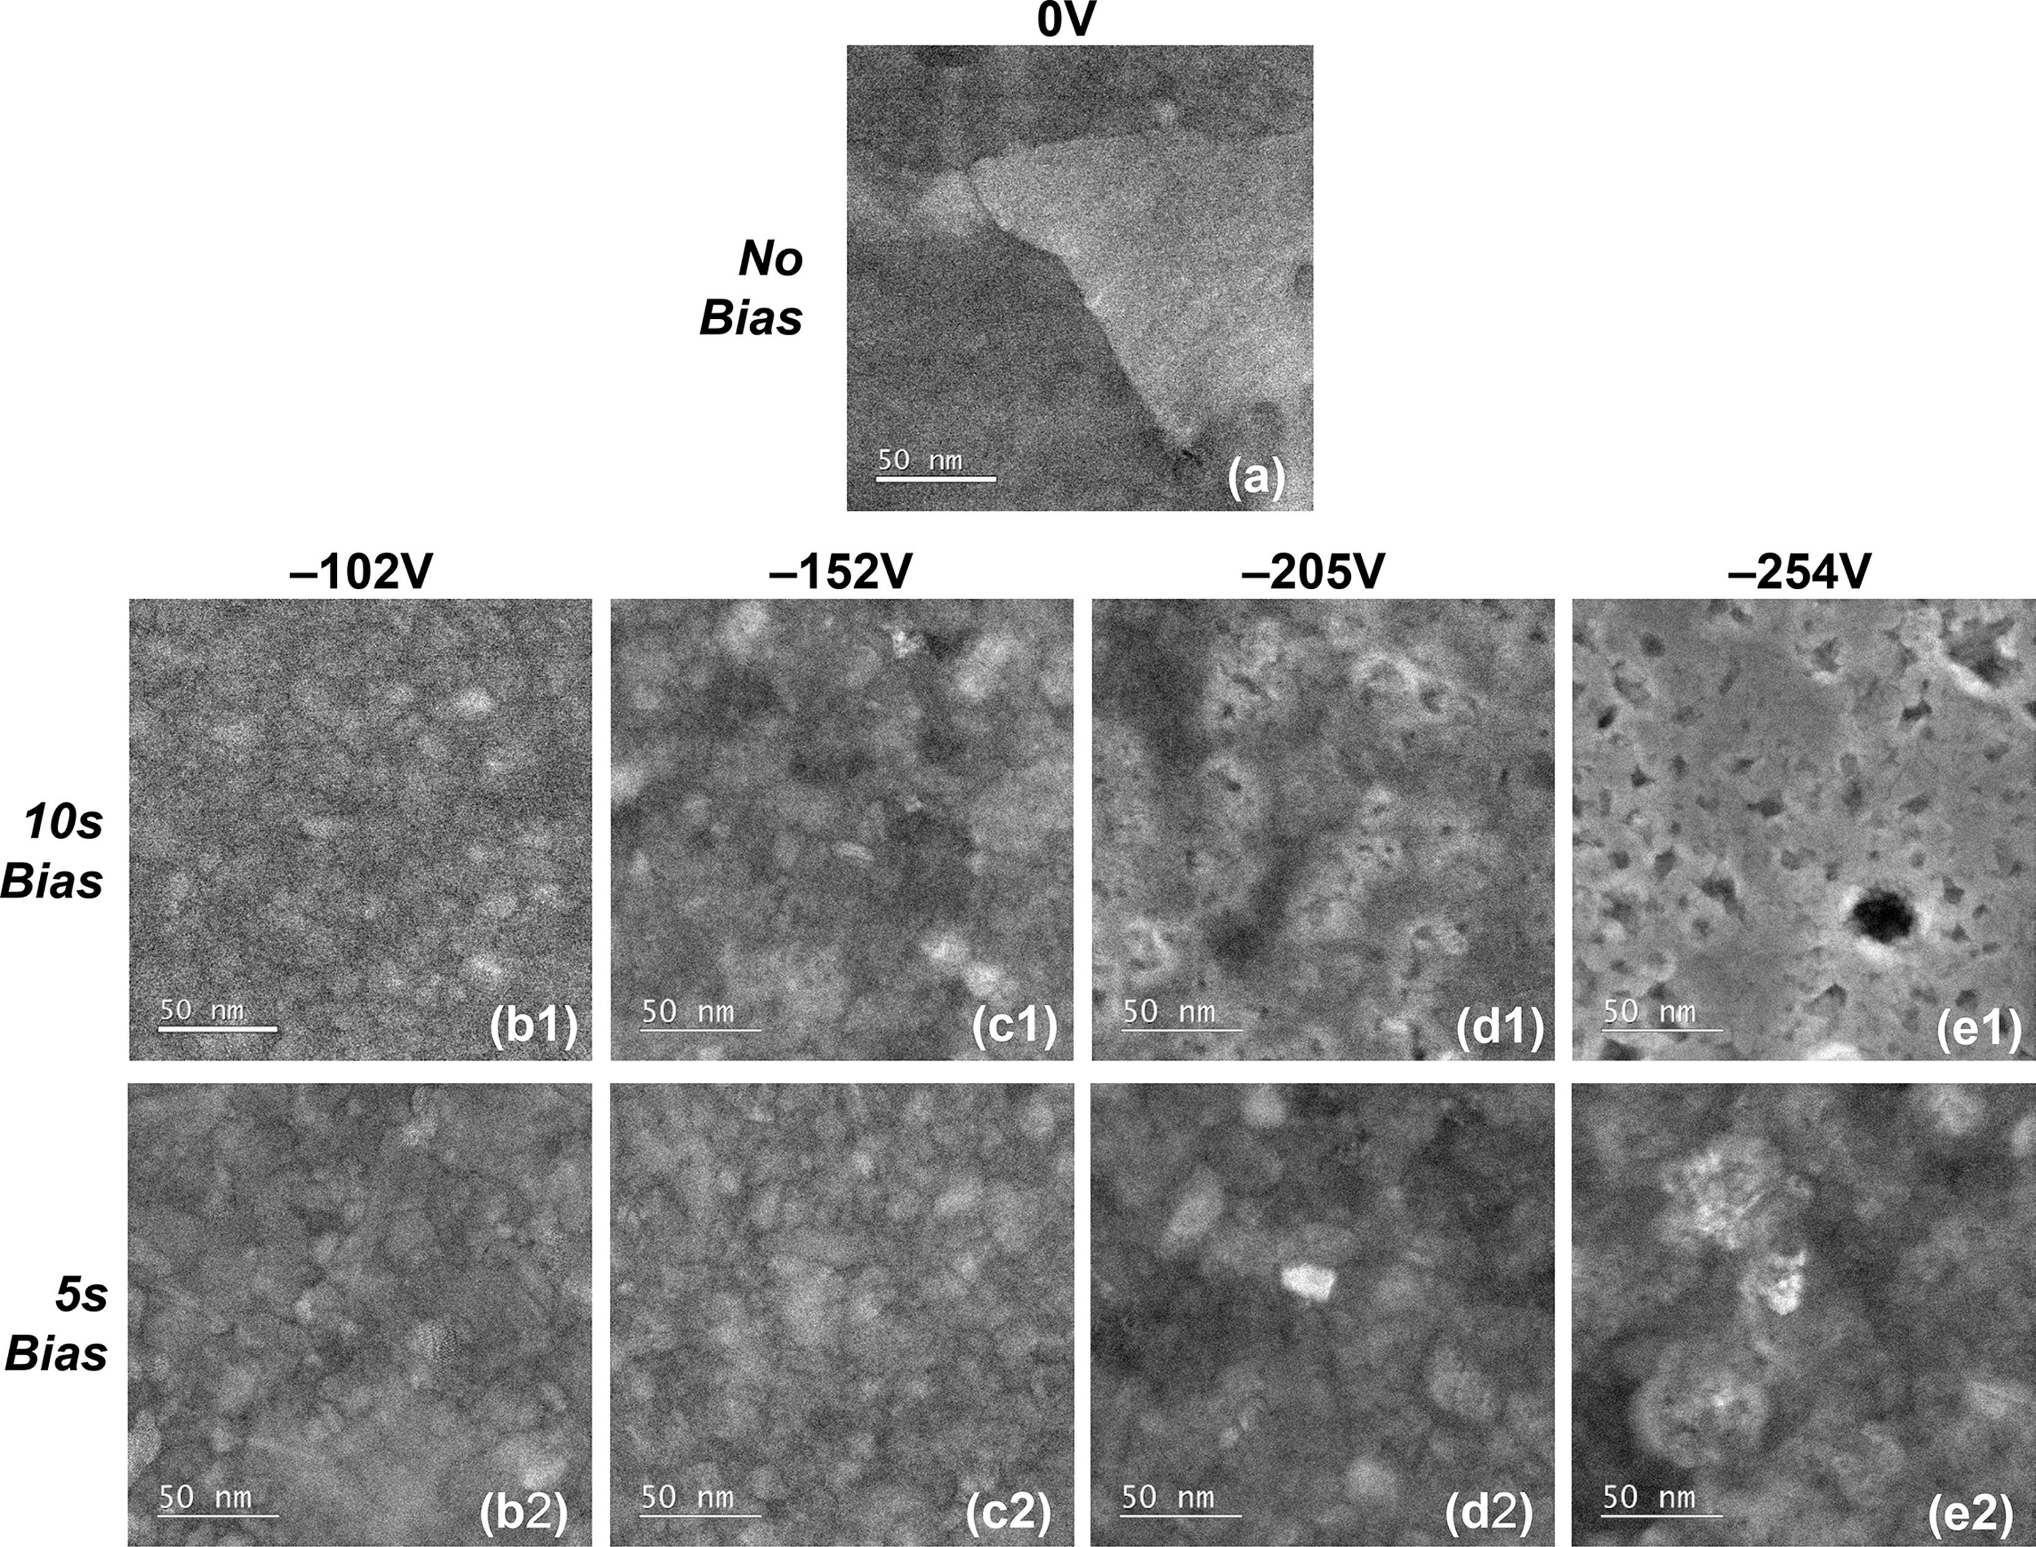

Figure 5. Plan-view high angle annular dark-field (HAADF) STEM images for titanium oxide films deposited at 300 °C with (a) 0 V, (b1 and b2) −102 V, (c1 and c2) −152 V, (d1 and d2) −205 V and (e1 and e2) −254 V average bias voltages, ⟨Vbias⟩. Images (b1), (c1), (d1), and (e1) denote ⟨Vbias⟩applied for the entire duration of the 10 s O2 plasma exposure step while images (b2), (c2), (d2), and (e2) represent ⟨Vbias⟩ applied for the last half (5 s) of the 10 s plasma exposure step.

using energetic particle bombardment.19,34−37The compressive stress reached a maximum as ⟨Vbias⟩ was increased to −152 V, similar to the peaking of refractive index and mass density with biasing at the same voltage. The maximization of compressive stress for deposition using energetic particle bombardment has been reported in the literature to be related to the formation of bombardment induced point defects, such as interstitials in the film bulk.34−37Under conditions of intense ion bombardment during film growth, the implantation of the energetic ions or the formation of subsurface interstitial atoms resulting from ion-surface interactions that push deposited atoms into the film bulk (i.e., recoil implantation or forward sputtering of knock-on atoms generated by ion-surface collisions) can increase atomic packing of the growing film.34−37This raises compressive stress as well as the mass density which scale with the concentration of those point defects.34−37The O/Ti ratio for the film deposited using−152 V applied for 10 s of plasma exposure was observed to increase to 2.2 ± 0.1 (Table 2) indicating the formation of an oxygen rich film during energetic oxygen ion bombardment. The excess oxygen can be speculated to be present as interstitial species which could stimulate an increase in compressive stress while also contributing toward elevating mass density and refractive index observed when increasing ⟨Vbias⟩ up to −152 V. Applying and steadily increasing ⟨Vbias⟩ to −152 V cause the anatase diffraction peaks in the XRD patterns (Figure 4a) to gradually decrease in magnitude while new peaks corresponding to the rutile phase of TiO2 appeared. This is similar to the results obtained in previous work conducted in our group where the crystalline phase of TiOx films, grown using different precursors19,20in a home-built plasma ALD tool equipped with

G DOI: [10.1021/acsami.8b00183](http://dx.doi.org/10.1021/acsami.8b00183)

|  |  |  |
| --- | --- | --- |
| ACS Applied Materials & Interfaces | |  | | --- | | Research Article | |

indicating an increase in the degree of disorder or amorphization of the film microstructure. This onset of amorphization induced

by highly energetic ion bombardment has also been reported in the literature14,37,38and it could play a role in lowering the refractive index and mass density of the films. Furthermore, the

relaxation of compressive stress on increasing ⟨Vbias⟩ beyond−152 V suggests that the yield strength of the material could have

been exceeded under such intense ion bombardment, which could then lead to plastic deformation.14,36,39,40These

aforementioned trends in material properties were in line with the appearance of voids in the film microstructure for TiOx deposited with ⟨Vbias⟩ greater than −152 V (Figure 5d1 and e1). The void fraction increased with increasing ⟨Vbias⟩, which could also play a role in compressive stress relaxation together with

decreasing refractive index and mass density. The surface of TiOx films initially became smoother with biasing as the RMS roughness decreased at −102 V (Figure 3e). This could be due to a combined effect of phase transformation, material densification and/or coalescence at grain boundaries due to enhanced mobility of surface species induced by energetic ions37 during film growth. The roughness increased with further increase in ⟨Vbias⟩ to −254 V, which could be attributed to the onset of void incorporation or ion bombardment induced surface damage.37The trends in RMS surface roughness obtained from

XRR were corroborated with additional measurements per-

formed using atomic force microscopy (see [Figure S5 and S6](http://pubs.acs.org/doi/suppl/10.1021/acsami.8b00183/suppl_file/am8b00183_si_001.pdf)).

Altogether, the results above demonstrate how the growth and material properties of TiOx films deposited using TDMAT and O2 plasma can be tuned by altering the magnitude of ⟨Vbias⟩applied with a 100% duty cycle during the plasma exposure step

of PEALD.

Effect of Bias Duration/Duty Cycle. When ⟨Vbias⟩ having the same magnitude but different duty cycle was applied during the

O2 plasma exposure step (i.e., the last 5 s of the 10 s plasma exposure, bias duty cycle = 50%, Figure 1c), differences were observed in the variation of TiOx film properties. The GPC again showed a trend of increasing with ⟨Vbias⟩, but at a slower rate than the 10 s bias condition reaching a comparatively lower value at−254 V (Figure 3a). This was also the case for GPC [Ti] and

GPC [O] values (Table 2), which increased to comparatively lower values at −205 V applied for the shorter 5 s of plasma exposure. The refractive index and mass density of the films also

increased with biasing for the shorter 5 s condition, but were consistently higher than the corresponding values for films

deposited using the same ⟨Vbias⟩ applied for a longer duration of 10 s (Figure 3b and c). The refractive index and mass density for

the 5 s bias condition reached higher maximum values at a higher⟨Vbias⟩ of −205 V compared to the corresponding peaks at −152 V obtained using the 10 s bias condition (Figure 3b and c). The residual stress of the TiOx films again changed from tensile to compressive for the 5 s bias condition and also reached a higher maximum at a higher ⟨Vbias⟩ of −205 V compared to the maximum obtained at −152 V using the 10 s bias condition (Figure 3d). The O/Ti ratio for the film deposited using −205 V applied for the shorter duration of 5 s was 2.3 ± 0.1 (Table 2) which again indicates the formation of an oxygen rich film during

energetic oxygen ion bombardment. Since compressive stress

tends to scale with the concentration of point defects such as interstitials,34−37the higher fraction of excess oxygen in the film grown with −205 V applied for the shorter duration of 5 s could

explain why it had a higher compressive stress, mass density and refractive index compared to the film grown with −152 V applied for 10 s. It is worth noting that the use of −102 V for the shorter

H DOI: [10.1021/acsami.8b00183](http://dx.doi.org/10.1021/acsami.8b00183)

|  |  |  |
| --- | --- | --- |
| ACS Applied Materials & Interfaces | |  | | --- | | Research Article | |

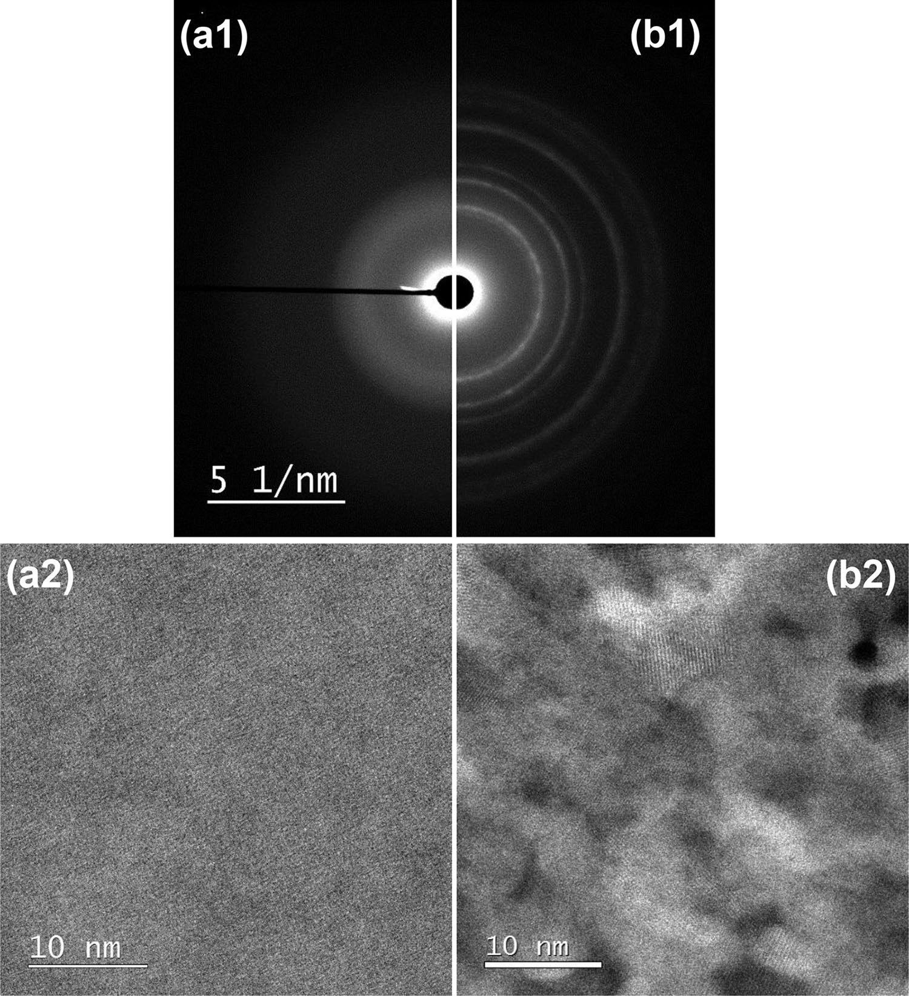

Figure 6. (a1, b1) Selected area electron diffraction patterns and (a2, b2) plan-view high angle annular dark-field (HAADF) STEM images for titanium oxide films deposited at 150 °C. Panels (a1) and (a2) are for the film deposited without substrate biasing (⟨Vbias⟩ = 0 V) while panels (b1) and (b2) are for the film deposited with substrate biasing (⟨Vbias⟩ =−205 V) applied during 10 s of the O2 plasma exposure step.

XRD pattern. The results obtained in this work using a different precursor (TDMAT) effectively reproduce the phenomenon of

inducing crystalline material formation with substrate biasing at a

comparatively lower temperature that would typically yield amorphous films.

Hafnium Oxide (HfOx). The growth and material properties of HfOx films deposited on planar substrates at 150 °C were investigated for ⟨Vbias⟩ between 0 and −280 V applied during the O2 plasma exposure step. Figure 7 shows these properties in terms of the GPC, refractive index, mass density, residual stress

and surface roughness expressed as a function of ⟨Vbias⟩ applied during plasma exposure. The crystalline properties of the HfOx films can be analyzed in Figure 8 which shows grazing incidence XRD patterns for films deposited with ⟨Vbias⟩ ranging from 0 to−280 V. Additional information regarding the crystallinity and film microstructure can be obtained in Figure 9 which shows selected area electron diffraction patterns and plan-view HAADF

STEM images for HfOx deposited on planar TEM windows with and without substrate biasing.

For deposition without any bias voltage, the film had a GPC of 1.03 ± 0.02 Å and a refractive index of 2.04 ± 0.03 (Figure 7a and b) which are comparable to the values reported by Sharma et al.25

for HfOx deposited using TDMACpH and O2 plasma at the same temperature. The film was observed to have a mass density of 9.0± 0.2 g/cm3(Figure 7c). The lack of diffraction peaks in the XRD

pattern (Figure 8) indicate the formation of amorphous HfOx deposited without biasing. This is confirmed by diffuse rings in the electron diffraction pattern (Figure 9a1) and absence of

lattice fringes in the HAADF STEM image (Figure 9a2). A void

rich amorphous matrix is also revealed in the HAADF STEM

image which could explain the low mass density and refractive index of this film when compared to bulk HfOx.41,42The film had a tensile residual stress of 770 ± 50 MPa (Figure 7d) which is comparable to that reported for HfOx in previous work.30 When substrate biasing was implemented during plasma

exposure, the GPC showed a slow increase with ⟨Vbias⟩ up to−204 V (Figure 7a). Further increase in ⟨Vbias⟩ to −280 V led to a

I DOI: [10.1021/acsami.8b00183](http://dx.doi.org/10.1021/acsami.8b00183)

|  |  |  |
| --- | --- | --- |
| ACS Applied Materials & Interfaces | |  | | --- | | Research Article | |

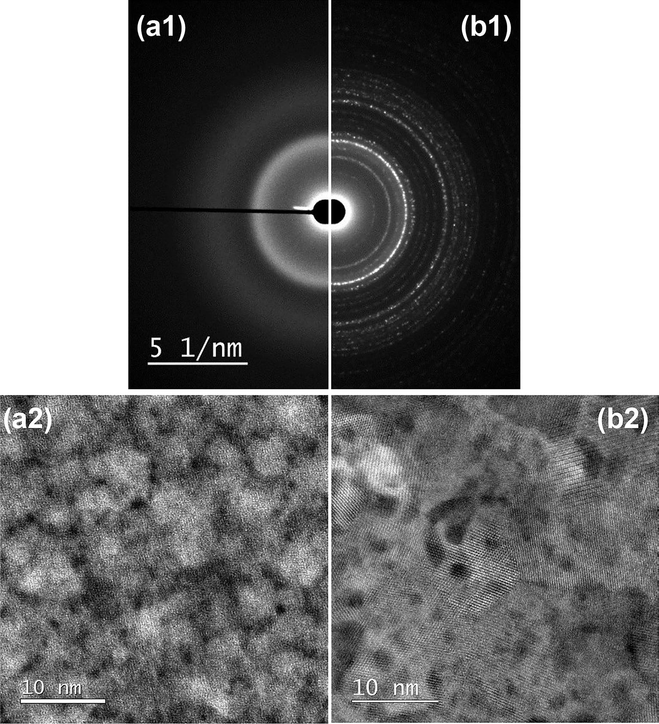

Figure 9. (a1, b1) Selected area electron diffraction patterns and (a2, b2) plan-view high angle annular dark-field (HAADF) STEM images for hafnium oxide films deposited at 150 °C. Panels a1 and a2 are for the film deposited without substrate biasing (⟨Vbias⟩ = 0 V) while panels b1 and b2 are for the film deposited with substrate biasing (⟨Vbias⟩ = −204 V) applied during the O2 plasma exposure step.

The phenomenon of crystalline material formation with substrate biasing at low temperature discussed previously for TiOx was also effectively demonstrated in case of HfOx. Increasing ⟨Vbias⟩ to −152 V led to higher diffraction peak intensities and narrower peak widths indicating the presence of a higher crystalline fraction and formation of larger crystal grains.43 Therefore, the observed increase in GPC, refractive index and mass density with ⟨Vbias⟩ can be initially attributed to the formation of crystalline material at −113 V, followed by an increase in crystalline content and/or grain size at −152 V. The increase in refractive index and mass density with biasing could in principle, also be due to a reduction in void content observed for the film grown without biasing. A similar increase in film crystallinity, refractive index and mass density of HfOx films was reported by Sharma et al.25due to an increase in substrate temperature. Therefore, the results obtained in this work demonstrate that enhancing the ion energy during PEALD of HfOx provides an alternate route for tuning such properties. Unlike the previous case of TiOx or any other material investigated in this work, the residual stress of HfOx showed a three stage behavior. In the first stage, the tensile residual stress of the HfOx films increased with ⟨Vbias⟩ to 1960 ± 50 MPa at −113 V (Figure 7d). This is in contrast to the trend exhibited by TiOx, which showed a change in stress from tensile to compressive when applying a similar ⟨Vbias⟩. The difference in stress behavior could be due to the difference in initial microstructure of the two films grown without biasing. TiOx deposited at a higher temperature (300 °C) yielded a highly crystalline and void-free film, whereas HfOx deposited at a lower temperature (150 °C) consisted of a void rich amorphous matrix. Therefore, when applying a similar ⟨Vbias⟩ around −100 V, TiOx changed from one void-free crystalline state to another, whereas HfOx transitioned from a disordered and porous amorphous matrix to a more ordered crystalline structure, with perhaps a lower void content. Further increase in ⟨Vbias⟩ led to the second stage in stress behavior where HfOx went from a tensile maximum at −113 V to a compressive maximum at −152 V (Figure 7d). This may again

J DOI: [10.1021/acsami.8b00183](http://dx.doi.org/10.1021/acsami.8b00183)

|  |  |  |
| --- | --- | --- |
| ACS Applied Materials & Interfaces | |  | | --- | | Research Article | |

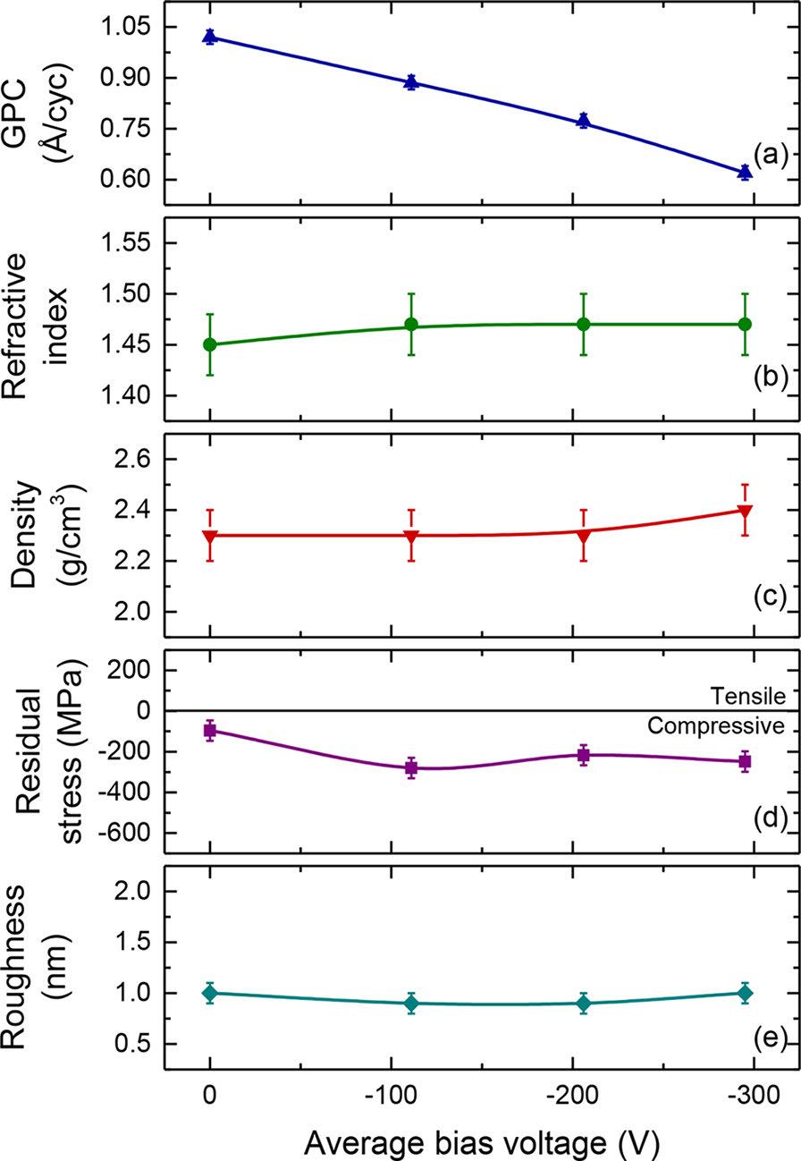

Figure 10. (a) Growth per cycle (GPC), (b) refractive index, (c) mass density, (d) residual stress, and (e) RMS surface roughness of silicon oxide films deposited at 200 °C expressed as a function of the average bias voltage, ⟨Vbias⟩, applied during the O2 plasma exposure step.

function of ⟨Vbias⟩ can be material specific. The refractive index of SiOx was observed to increase slightly to 1.47 ± 0.03 by applying⟨Vbias⟩ of −111 V, but did not increase beyond this value with further increase in biasing. The mass density was observed to remain fairly unchanged with biasing with a slight increase to 2.4± 0.2 g/cm3using ⟨Vbias⟩ of −295 V. The residual stress of the SiOx films remained compressive when deposited with substrate biasing and reached a maximum value of −280 ± 50 MPa at−111 V. Further increase in ⟨Vbias⟩ did not lead to any significant change in the compressive stress. The RMS surface roughness also remained fairly constant when using ⟨Vbias⟩ to deposit SiOx films. Unlike the significant variations in growth and material properties observed for TiOx and HfOx previously, the results for SiOx showed a significant variation in the growth rate but a very small change in material properties as a function of ⟨Vbias⟩ during plasma exposure. Further analysis of film OH content, optical transmission losses, wet-etch resistance, etc., will be reported in a subsequent publication that will provide more insight on the effects of substrate biasing during PEALD of SiOx.

PEALD of Nitrides on Planar Substrates. Titanium Nitride (TiNx). The growth and material properties of TiNx films deposited on planar substrates at 200 °C was investigated for ⟨Vbias⟩ between 0 V and −255 V applied during the Ar + H2 plasma exposure step. Figure 11 shows these properties in terms of the GPC, resistivity, mass density, residual stress, and surface roughness expressed as a function of ⟨Vbias⟩ applied during plasma exposure. Table 3 outlines additional growth and material properties from RBS analysis for the films deposited with and without substrate biasing. The growth properties are outlined in

K DOI: [10.1021/acsami.8b00183](http://dx.doi.org/10.1021/acsami.8b00183)

|  |  |  |
| --- | --- | --- |
| ACS Applied Materials & Interfaces | |  | | --- | | Research Article | |

Table 3. GPC (Film Thickness per Cycle and Number of Atoms Deposited per nm2per Cycle) and Elemental Composition of Titanium Nitride Films Deposited at 200 °C with and without Average Bias Voltages, ⟨Vbias⟩, Applied during the Ar + H2 Plasma Exposure Stepa

|  |  |  |  |  |  |  |  |  |  |
| --- | --- | --- | --- | --- | --- | --- | --- | --- | --- |
|  |  |  |  | RBS |  |  |  |  | ERD |
| ⟨Vbias⟩ | GPC | GPC [Ti] (# Ti at. per | GPC [N] (# N at. per | GPC [O] (# O at. per | N/Ti | [O] | [C] | [Ar] | [H] |
| (Å/cycle) | nm2per cycle) | nm2per cycle) | nm2per cycle) | at. % | at. % | at. % | at. % |
| (V) |
| 0 | 0.47 ± 0.02 | 1.22 ± 0.03 | 0.76 ± 0.10 | 0.92 ± 0.05 | 0.63 ± 0.06 | 28 ± 5 | <d.l.b | 0 ± 0.06 | 10 ± 7 |
| −130 | 0.35 | 1.46 ± 0.01 | 1.18 ± 0.04 | 0.10 ± 0.02 | 0.80 ± 0.02 | 3 ± 2 | <d.l. | 0.20 ± 0.05 | 3 ± 3 |
| −255 | 0.34 | 1.18 | 1.17 | 0.06 | 1.0 | 2 | 12 ± 3 | 0.77 | 2 |

aTypical uncertainties are given in the first and second rows unless otherwise stated. bValues below detection limit (d.l.) of 8 at. % for [C].

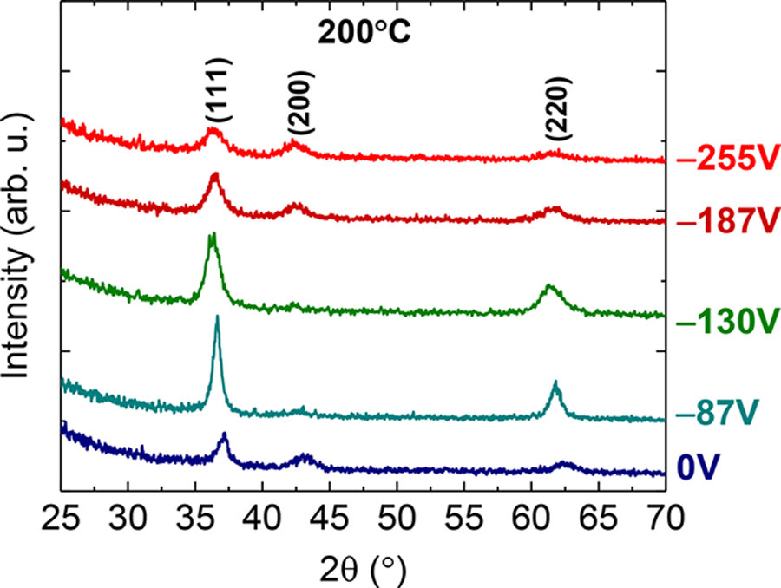

Figure 12. Grazing incidence X-ray diffractograms for titanium nitride films deposited at 200 °C with average bias voltages, ⟨Vbias⟩, ranging from 0 to −255 V applied during the Ar + H2 plasma exposure step. Peaks corresponding to lattice planes in cubic titanium nitride are indicated.

were incorporated in this film (Table 3). For deposition involving highly reactive materials such as Ti, Hf, Nb, etc., the partial pressure of the vacuum species (e.g., background water, oxygen) can influence the amount of impurity incorporation (e.g., up to tens of an atomic percent of oxygen) in the deposited film.26,36,46,47Assuming a partial pressure of ∼10−8Torr for

background impurities (for the base pressure of ∼10−6Torr in

the FlexAL system) corresponds to an impingement rate of about∼0.5 impurity atoms per nm2/s on the growing film surface.36,48

A plasma exposure time of 10 s can therefore, lead to the incorporation of ∼0.5 impurity at./nm2in the film (assuming a sticking coefficient of 1) which is of the same order as the GPC [O] value obtained for the TiNx film grown without biasing. Another reason for the significant [O] content could be due to oxidation of the film upon exposure to the environment. The film

was observed to have a tensile residual stress (Figure 11a) similar to that reported for TiNx in previous work.49The XRD pattern for this film (Figure 12) shows diffraction peaks that correspond

to cubic TiNx. The fairly small peak intensities and broad peak widths indicate the presence of small crystal grains. This was confirmed by complementary information in the magnified plan-view HAADF STEM image of the film (see [Figure S8a](http://pubs.acs.org/doi/suppl/10.1021/acsami.8b00183/suppl_file/am8b00183_si_001.pdf)). It showed small lateral grain sizes of the order of ∼5 nm based on

estimates of lattice fringe areas. A loosely packed microstructure

consisting of crystalline grains with porous regions in between

was also revealed. The small grain size together with

intergranular voids observed in the TEM image could also

contribute toward the high resistivity and low density of the TiNx film deposited without biasing.

When substrate biasing was applied during the last half (5 s) of

the 10 s Ar + H2 plasma exposure step, the trends in GPC, resistivity, mass density, and residual stress again consisted of two

stages as observed earlier for the transition metal oxides. In the

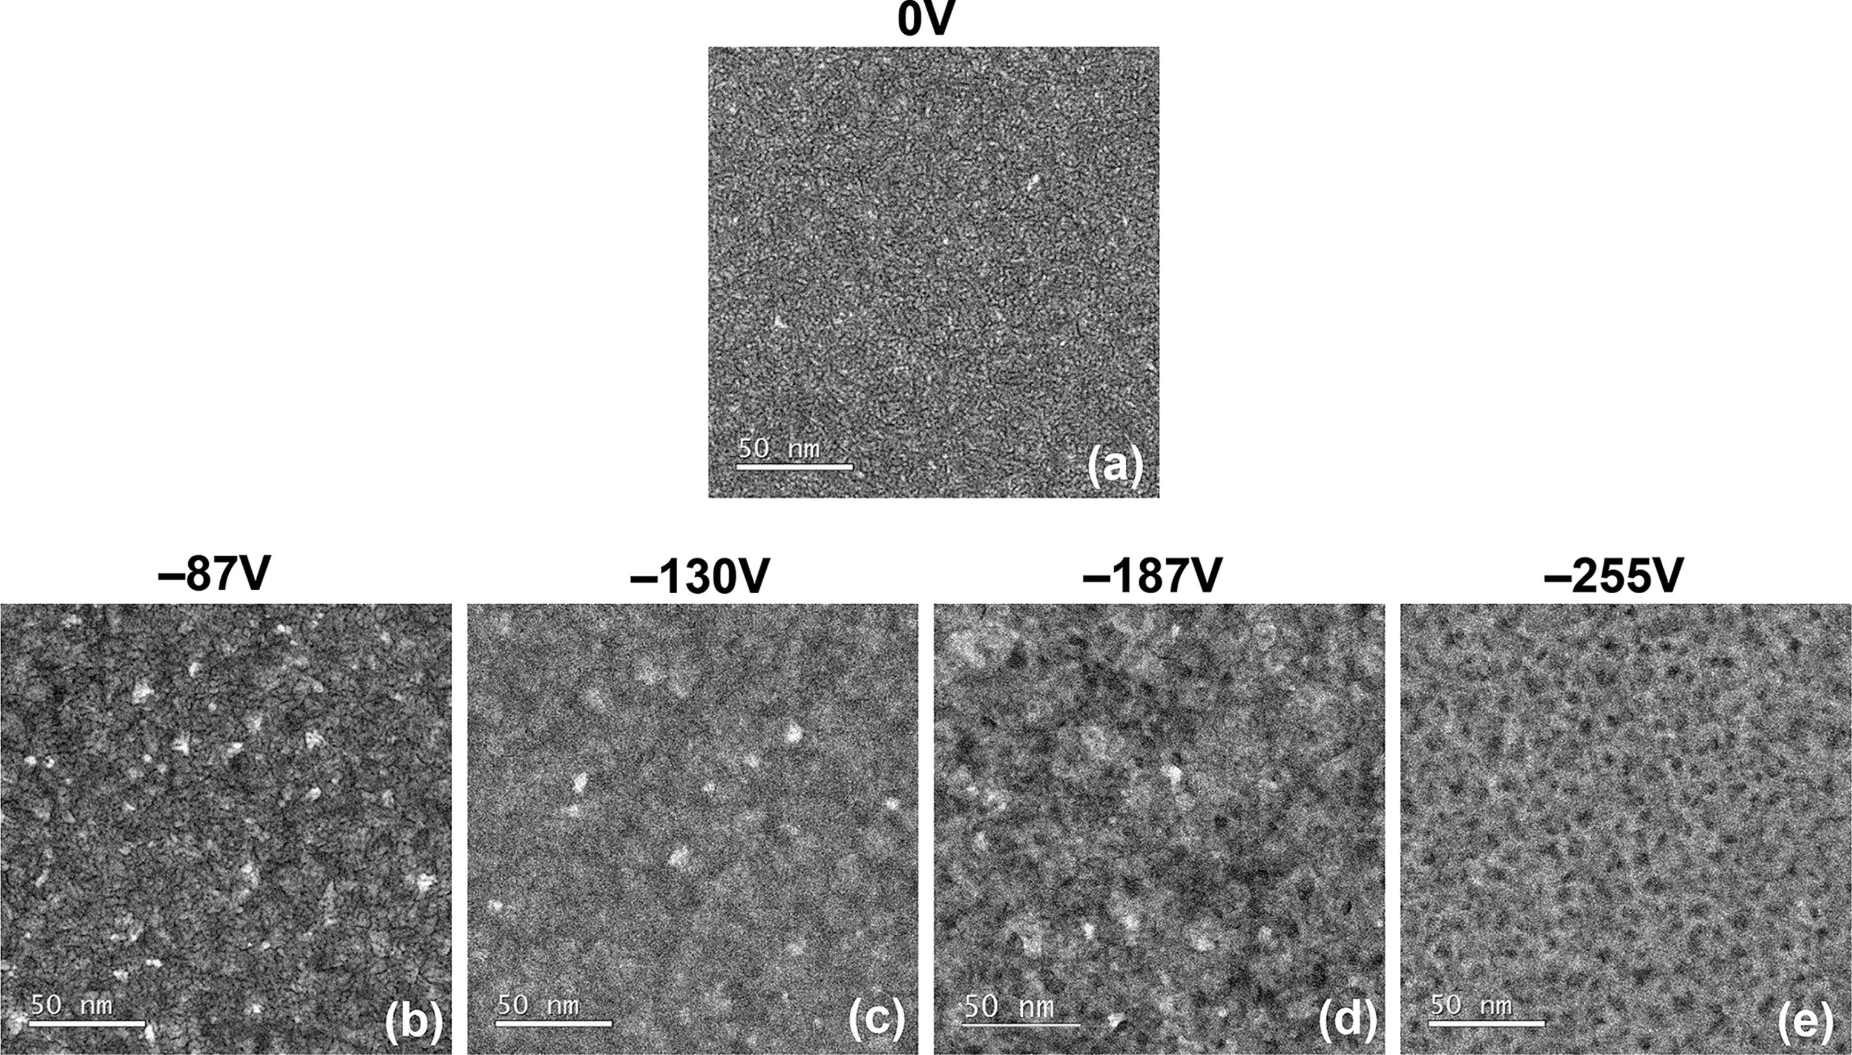

Figure 13. Plan-view high-angle annular dark-field (HAADF) STEM images for titanium nitride films deposited at 200 °C with (a) 0 V, (b) −87 V, (c)−130 V, (d) −187 V, and (e) −255 V average bias voltages, ⟨Vbias⟩, applied during the Ar + H2 plasma exposure step.

|  |  |
| --- | --- |
| L | DOI: [10.1021/acsami.8b00183](http://dx.doi.org/10.1021/acsami.8b00183) ACS Appl. Mater. Interfa[ces XXXX, XXX, XXX−XXX](http://dx.doi.org/10.1021/acsami.8b00183) |

|  |  |  |
| --- | --- | --- |
| ACS Applied Materials & Interfaces | |  | | --- | | Research Article | |

first stage, the GPC decreased with substrate biasing and reached a minimum value of 0.32 ± 0.02 Å at ⟨Vbias⟩ of −187 V (Figure 11a). This decrease in GPC for TiNx is unlike the trends in GPC observed for the transition metal oxide films discussed

previously, but similar to that observed for SiOx. This again illustrates how the trends in growth properties as a function of⟨Vbias⟩ can be material specific. The reduction in film GPC coincided with a 9-fold decrease in GPC [O] with biasing at−130 V (Table 3). The large decrease in GPC [O] outweighed

the comparatively smaller increase in GPC [Ti] and GPC [N] at−130 V (Table 3). As a result, a large reduction in the film [O] content to 3 ± 2 at. % and a simultaneous increase of the N/Ti ratio to 0.8 ± 0.03 (Table 3) was observed when ⟨Vbias⟩ was increased to −130 V. The [H] content also decreased significantly to 3 ± 3 at. % while any carbon impurities that may have been incorporated using −130 V still remained below the detection limit (Table 3). The significant decrease in [O] and

[H] impurity contents and improvement in TiNx stoichiometry was reflected in an order of magnitude lower resistivity and a higher mass density of 134 ± 5 μΩcm and 5.3 ± 0.2 g/cm3 (Figure 11b and c), respectively, at −130 V. Energetic ion

bombardment during deposition of TiNx 50 and other nitrides11,51has been reported to improve material purity by removing adsorbed oxygen/OH species from the growing film

surface originating from background impurities in the vacuum

environment. Therefore, the large reduction in [O] and [H]

impurity content by energetic ion bombardment during Ar + H2 plasma exposure with biasing can contribute toward lowering GPC, while improving film density and electronic conductivity. The residual stress behavior of the TiNx films in the first stage changed from tensile to compressive on applying ⟨Vbias⟩ to the substrate (Figure 11d). The compressive stress reached a maximum as ⟨Vbias⟩ was increased to −130 V, analogous to the minimum in resistivity and maximum in mass density obtained at

the same ⟨Vbias⟩. The stress evolution from tensile to compressive for deposition of TiNx using energetic particle bombardment could be due to the interplay of several factors discussed in the literature.44,45,52A part of the reason could be due to the change in film composition when increasing ⟨Vbias⟩ up to −130 V leading to the formation of cleaner TiNx films that have a higher bulk density compared to pure TiO2 or contaminated TiNxOyHz. Another factor that could play a role is inert argon gas

incorporation, even below 1 at. %, at interstitial positions which has been reported in the literature to induce significant compressive stress.44,52This is in agreement with the small but measurable quantity of 0.20 ± 0.05 at. % for [Ar] in the highly compressive TiNx film deposited using −130 V (Table 3). Analysis of film crystalline properties revealed that applying

⟨Vbias⟩ initially led to more intense and narrower (111) and (220) peaks while suppressing the (200) peak, as observed in the XRD pattern for −87 V (Figure 12). This suggests the presence of a

more crystalline material with larger grains which was corroborated by the magnified HAADF STEM image of the film deposited using −87 V (see [Figure S8b](http://pubs.acs.org/doi/suppl/10.1021/acsami.8b00183/suppl_file/am8b00183_si_001.pdf)). It showed increased lateral grain dimensions of the order of ∼10 nm and a more closely packed film microstructure with a reduced void fraction. However, further increase in ⟨Vbias⟩ to −130 V led to a gradual decrease in intensity and broadening of the (111) and (220)

peaks in the XRD pattern while the (200) peak slowly reappeared

(Figure 12). Although this seems to suggest a decrease in the crystalline order or grain size, the TEM image of the film deposited at −130 V (Figure 13c) revealed a very compact TiNx film with a void-free microstructure that retained grain

M DOI: [10.1021/acsami.8b00183](http://dx.doi.org/10.1021/acsami.8b00183)

|  |  |  |
| --- | --- | --- |
| ACS Applied Materials & Interfaces | |  | | --- | | Research Article | |

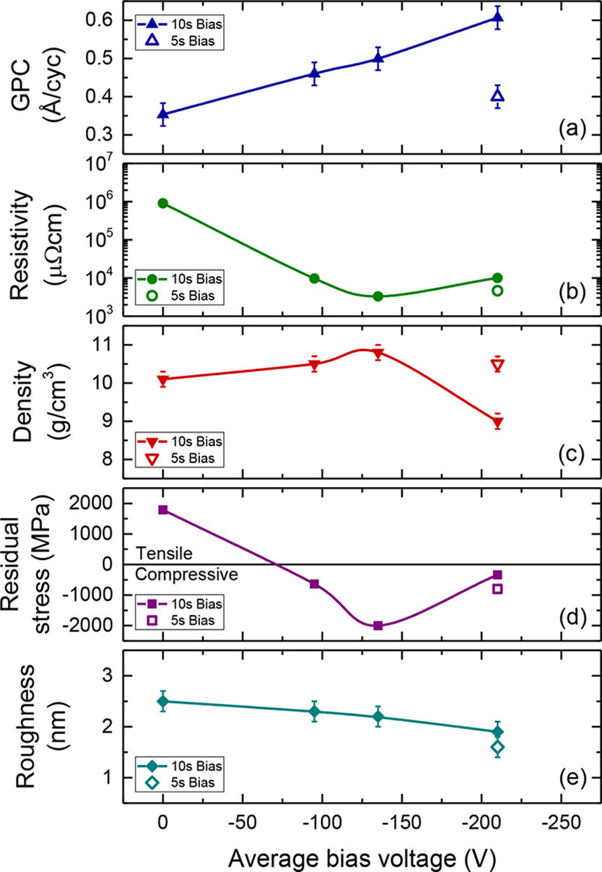

Figure 14. (a) Growth per cycle (GPC), (b) resistivity, (c) mass density, (d) residual stress, and (e) RMS surface roughness of hafnium nitride films deposited at 450 °C expressed as a function of the average bias voltage, ⟨Vbias⟩, applied for the entire duration and last half (5 s, only for⟨Vbias⟩ = −210 V) of the 10 s H2 plasma exposure step.

a resistivity of (90 ± 7) × 104μΩcm (Figure 14a and b) which are comparable to the values reported by Karwal et al.26for HfNx deposited using TDMACpH and H2 plasma at the same temperature. The low film conductivity was attributed to a high oxygen impurity content of 15 at. % that got incorporated in the film mainly during deposition due to background water present in the ∼10−6Torr vacuum environment of the ALD system,26similar to what was speculated previously for TiNx. The HfNx film deposited without biasing was also observed to have a mass density of 10.1 ± 0.2 g/cm3, tensile residual stress of 1786 ±50 MPa and an RMS surface roughness of 2.5 ± 0.2 nm (Figure 14c, d and e).

For the 10 s bias duration condition (bias duty cycle = 100%, Figure 1b), the GPC showed a monotonic increase with increasing ⟨Vbias⟩ (Figure 14a). This is in contrast to the initial dip followed by a gradual rise in GPC as a function of ⟨Vbias⟩observed earlier for TiNx, but similar to the corresponding trends for TiOx and HfOx. However, the film resistivity, mass density and residual stress showed a two stage behavior with increasing⟨Vbias⟩, similar to the trends seen before for TiNx. The use of substrate biasing during the plasma exposure step was observed to trigger a drastic improvement in the electronic properties of HfNx through a reduction in film resistivity by 2 orders of magnitude (Figure 14b). For the 10 s bias duration condition, increasing ⟨Vbias⟩ led to an initial decrease in film resistivity that reached a minimum value of (33 ± 7) × 102μΩcm at −130 V. The mass density initially increased slightly with biasing and reached a peak at the same voltage (Figure 14b). In the initial stage, the residual stress changed from tensile to compressive on applying ⟨Vbias⟩ during plasma exposure. The compressive stress

N DOI: [10.1021/acsami.8b00183](http://dx.doi.org/10.1021/acsami.8b00183)

|  |  |  |
| --- | --- | --- |
| ACS Applied Materials & Interfaces | |  | | --- | | Research Article | |

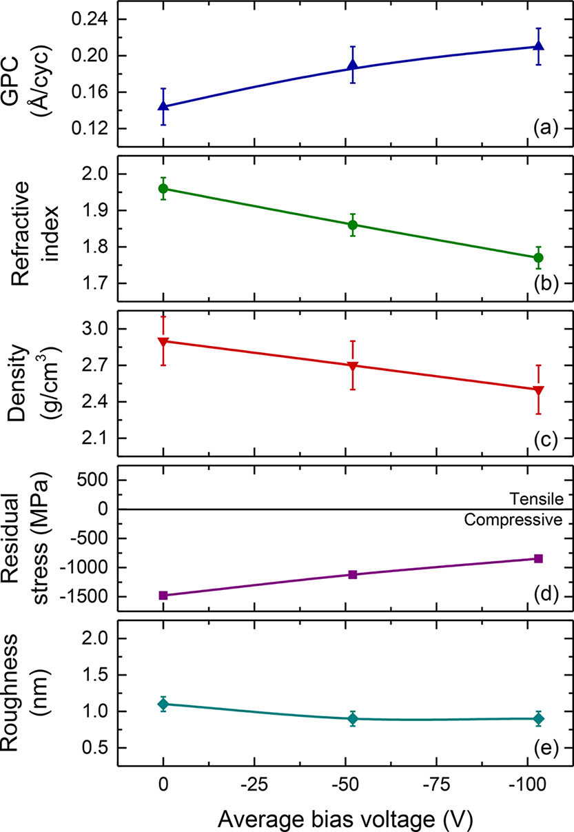

Figure 15. (a) Growth per cycle (GPC), (b) refractive index, (c) mass density, (d) residual stress, and (e) RMS roughness of silicon nitride films deposited at 500 °C expressed as a function of the average bias voltage, ⟨Vbias⟩, applied during the N2 plasma exposure step.

found to be compressive in nature (Figure 15d) similar to that reported previously for SiNx deposited at a comparable temperature.54The nature of the stress for SiNx is unlike the tensile stresses observed earlier for the transition metal compounds deposited without biasing but similar to the compressive stress obtained for SiOx. An N/Si ratio of 1.4 ±0.1 was observed for this film (Table 4) indicating the formation of nearly stoichiometric Si3N4 (N/Si ratio of 1.33) for deposition without any biasing. Low impurity contents in terms of [O], [C], and [H] (2 ± 2 at. %, < 8 at. % and 4 ± 3 at. %, respectively) were measured for this film (Table 4) indicating the formation of high quality SiNx.

For deposition with substrate biasing, the GPC showed a monotonic increase with ⟨Vbias⟩ (Figure 15a). Although GPC [Si] remained fairly unchanged, the increase in GPC could be partly explained by an increase in GPC [N] that reached a value of 0.91 ± 0.04 N at./nm2at −103 V (Table 4). This indicated the formation of a nitrogen rich film with increase in ⟨Vbias⟩, which was corroborated by a higher N/Si ratio of 1.7 obtained for

deposition using −103 V (Table 4). The refractive index and mass density showed a monotonic decrease with ⟨Vbias⟩ (Figure 15b and c). The trends in refractive index and mass density were accompanied by a relaxation of the compressive stress as a function of ⟨Vbias⟩ (Figure 15d). The film surface became slightly smoother as the RMS roughness decreased with increasing⟨Vbias⟩ (Figure 15e). The impurity contents increased with ⟨Vbias⟩as observed by the elevated [O], [C], and [H] values at −103 V (Table 4). The simultaneous decrease in refractive index, mass density, and compressive stress together with an increase in the impurity content indicate that energetic ion bombardment through substrate biasing during PEALD of SiNx degrades its material properties on planar substrates. These monotonic trends in refractive index, mass density and residual stress of SiNx deposited using relatively small ⟨Vbias⟩ (≤−100 V) are unlike any of the trends observed previously for other materials investigated in this work. It suggests that even the slightest increase in ion energies during N2 plasma exposure could induce plastic deformation,14,36,39,40excess nitrogen content, N2 gas bubble formation,14,55and void incorporation, which could then be factors responsible for film quality degradation. This sort of material degradation was also observed in the other materials (except SiOx) but only when using comparatively higher ⟨Vbias⟩(≥−130 V), indicating the presence of higher ion energy thresholds for degradation in those materials.

Thickness Uniformity on 200 mm Substrates. The thickness uniformity of films on large-area planar substrates (200 mm c-Si wafers) was investigated for all six oxides and nitrides deposited with and without substrate biasing. Note that the results obtained were not from optimized precursor dose and plasma exposure times intended for attaining the best uniformities but serve to demonstrate the role of substrate biasing on thickness uniformity during PEALD on large-area substrates. The thickness nonuniformity was defined as the ratio of the standard deviation in thicknesses measured at several points across the wafer to the average thickness of all data points measured. The values obtained are expressed as percentages in Table 5. The results show that for most cases the thickness uniformity of films on 200 mm substrates improved when using substrate biasing during PEALD, except for HfOx and SiNx, where the uniformity remained fairly unchanged. For TiOx deposited with biasing, the change in thickness nonuniformity was also observed to depend on the duration or duty cycle of the bias applied during O2 plasma exposure. The use of a longer bias duration (10 s) increased nonuniformity to 2.8%, whereas the same ⟨Vbias⟩ applied for a shorter bias duration (5 s) decreased nonuniformity to 2.0% relative to the nonuniformity of the film grown without biasing (2.3%). The two transition metal nitride films deposited without biasing had the highest thickness nonuniformities on 200 mm planar substrates (7.5% for TiNx, 9.4% for HfNx). The use of substrate biasing during PEALD of

Table 4. GPC (Film Thickness Per Cycle and Number of Atoms Deposited per nm2per Cycle) and Elemental Composition of Silicon Nitride Films Deposited at 500 °C with and without Average Bias Voltages, ⟨Vbias⟩, Applied during the N2 Plasma Exposure Stepa

|  |  |  |  |  |  |  |  |
| --- | --- | --- | --- | --- | --- | --- | --- |
|  |  |  | RBS |  |  |  | ERD |
| ⟨Vbias⟩ | GPC | GPC [Si] | GPC [N] | N/Si | [O] | [C] | [H] |
| (V) | (Å/cycle) | (# Si at. per nm2per cycle) | (# N at. per nm2per cycle) | at. % | at. % | at. % |
| 0 | 0.14 ± 0.02 | 0.55 ± 0.02 | 0.79 ± 0.04 | 1.4 ± 0.1 | 2 ± 2 | <d.l.b | 4 ± 3 |
| −103 | 0.21 | 0.53 | 0.91 | 1.7 | 10 | 8 ± 3 | 6 |

aTypical uncertainties are given in the first row unless otherwise stated. bValues below detection limit (d.l.) of 8 at. % for [C].

|  |  |
| --- | --- |
| O | DOI: [10.1021/acsami.8b00183](http://dx.doi.org/10.1021/acsami.8b00183) ACS Appl. Mater. Interfa[ces XXXX, XXX, XXX−XXX](http://dx.doi.org/10.1021/acsami.8b00183) |

|  |  |  |
| --- | --- | --- |
| ACS Applied Materials & Interfaces | |  | | --- | | Research Article | |

Table 5. Thickness Uniformity of Films Deposited on 200 mm Planar c-Si Wafers without and with Average Bias Voltages,⟨Vbias⟩, Applied during Plasma Exposure Steps

|  |  |  |  |
| --- | --- | --- | --- |
|  | No substrate bias (%) | With substrate bias (%) | ⟨Vbias⟩(V) |
| titanium oxide | 2.3 | 2.8a, 2.0b | −205 |
| hafnium oxide | 4.6 | 4.6 | −152 |
| silicon oxide | 1.1 | 0.7 | −200 |
| titanium nitride | 7.5 | 6.6 | −187 |
| hafnium nitride | 9.4 | 7.7a, 6.7b | −210 |
| silicon nitride | 3.5 | 3.6 | −103 |

aSubstrate biasing applied for the entire duration of the plasma exposure step.bSubstrate biasing applied for the last half of the plasma exposure step.

these two nitrides led to the most significant improvements in thickness uniformity among all the materials. For TiNx deposited using −187 V, the thickness nonuniformity decreased to 6.6%, while for HfNx deposited using −210 V (applied for the entire duration of the 10 s H2 plasma exposure step), the thickness nonuniformity decreased to 7.7%. Interestingly, when HfNx was deposited using the same ⟨Vbias⟩ but a lower bias duration of 5 s, the thickness nonuniformity decreased to an even lower value of 6.7%. These results demonstrate that both the ion energy and the dose of higher energy ions can play roles in altering film uniformity.

PEALD on 3D Substrates. Titanium Oxide (TiOx). The cross-sectional TEM image of a TiOx layer on 3D trench nanostructures is shown in Figure 16. The film was deposited at

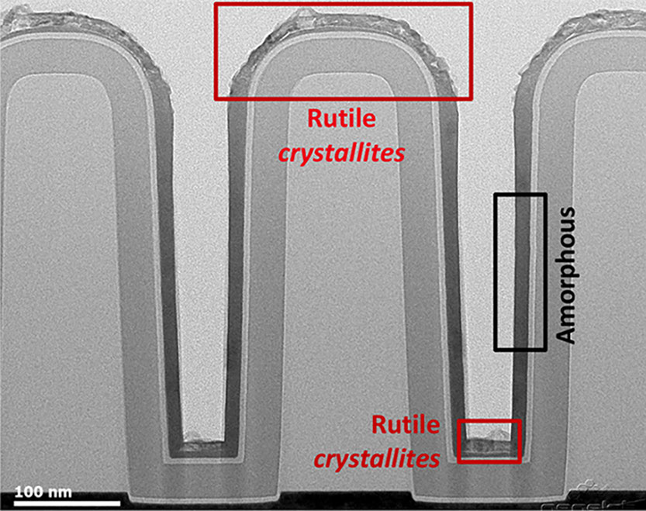

Figure 16. Cross-sectional TEM image of titanium oxide film on 3D trench nanostructures (AR = 4.5:1) deposited at 150 °C with an average bias voltage (⟨Vbias⟩ = −205 V) applied during the entire duration of the 10 s O2 plasma exposure step. The presence of crystalline material (rutile) on planar surfaces and amorphous material on vertical sidewall surfaces are indicated.

150 °C using −205 V applied during the entire duration of the 10 s O2 plasma exposure step. Film conformalities of 84% and 100% were measured at the bottom-side and bottom regions of the trench, respectively (see [Figure S9](http://pubs.acs.org/doi/suppl/10.1021/acsami.8b00183/suppl_file/am8b00183_si_001.pdf)). As discussed before, an increase in film GPC was observed during PEALD of TiOx with substrate biasing on planar substrates. This can cause film GPCs at the planar top and bottom surfaces of the 3D trench nanostructure to exceed the GPC at the vertical bottom-side region and thereby yield a lower conformality at that region of the 3D substrate. Furthermore, the effect of enhanced ion energies is also visible in Figure 16 in terms of the different

P DOI: [10.1021/acsami.8b00183](http://dx.doi.org/10.1021/acsami.8b00183)

|  |  |  |
| --- | --- | --- |
| ACS Applied Materials & Interfaces | |  | | --- | | Research Article | |

HfOx film grown at the vertical sidewall surface regions can be assumed to be amorphous. This can again be attributed to the role of directional ions traveling through a nearly collisionless plasma sheath that bombard planar surface regions of the 3D trench nanostructures with more energy than the vertical sidewalls when implementing substrate biasing. The results obtained for HfOx effectively reproduce the phenomenon seen earlier for TiOx, where enhancing the energy of directional oxygen ions during film deposition induced simultaneous growth of different phases (crystalline and amorphous) of the same material at different surfaces (planar and vertical) of a 3D substrate.

Silicon Nitride (SiNx). Cross-sectional TEM images of SiNx layers on 3D trench nanostructures are shown in Figure 18. The images for as-deposited films grown at 500 °C without any substrate biasing and with −103 V during N2 plasma exposure are shown in Figure 18A and B, respectively. Conformalities of 37% and 56% were obtained at the bottom-side and bottom of the trench structures, respectively, for the film deposited without any⟨Vbias⟩ (Figure 18A), similar to the values reported by in our previous work28for SiNx deposited on such 3D substrates. The bottom-side film conformality improved slightly to 39% while that at the bottom improved significantly to 78% for the film deposited using −103 V during N2 plasma exposure (Figure 18B). Note that some significant corner tapering was observed for the SiNx film deposited with −103 V. The quality of these SiNx films was analyzed by measuring their etch resistance in dilute hydrofluoric acid solution (HF:H2O = 1:100). The as-deposited films underwent a 30 s wet-etch treatment in dilute HF and cross-sectional TEM images of the films were measured after the etch treatment. Figure 18A′ and B′ show the post wet-etch TEM images of the films deposited without any substrate biasing and with −103 V applied during N2 plasma exposure, respectively. The wet-etch rate (WER) values were determined by comparing the as-deposited and post wet-etch film thicknesses at three different regions (top, bottom-side, bottom) of the 3D trench nanostructures which are outlined in Table 6. The SiNx film deposited without biasing seemed to be highly etch resistant at the planar top and bottom regions of the trench as indicated by the small or insignificant WER values (≤1 ± 1 nm/ min, Table 6) at those regions. These low WERs indicate the formation of high quality SiNx films on planar top and bottom surfaces of the 3D trench nanostructures for deposition without any substrate biasing. This is also in agreement with the high mass density, refractive index (Figure 15b, c) and low impurity content (Table 4) of SiNx deposited without biasing on a planar c-Si substrate, as discussed earlier. The WER observed at the bottom-side region of the trench (3 ± 1 nm/min, Table 6) is relatively higher than those at the two planar trench regions, indicating a reduced HF-etch resistance of SiNx at the vertical trench sidewalls. However, the value is small in absolute magnitude indicating an overall high HF-etch resistance at both planar and vertical trench surfaces for the film deposited without substrate biasing. For the SiNx film deposited with −103 V during N2 plasma exposure, the film regions located at the planar top and bottom surfaces of the trench exhibited very high WERs and were completely removed after the etch treatment (Figure 18B′). These high WERs indicate the degradation of SiNx films on planar top and bottom surfaces of the 3D trench nanostructures for deposition with substrate biasing. This is corroborated by the lower refractive index, mass density (Figure 15b, c) and higher impurity content (Table 4) observed earlier for SiNx deposited on planar substrates using −103 V during N2

Q DOI: [10.1021/acsami.8b00183](http://dx.doi.org/10.1021/acsami.8b00183)

|  |  |  |
| --- | --- | --- |
| ACS Applied Materials & Interfaces | |  | | --- | | Research Article | |

again be explained by the combined factors of high energy and directionality of ions traveling through a nearly collisionless plasma sheath when ⟨Vbias⟩ is applied to the substrate. These energetic ions collide with much more energy on the horizontal top and bottom surfaces of the 3D trenches than the vertical sidewalls. Consequently, the SiNx films growing at the top and bottom trench regions are selectively degraded in comparison to those growing at the sidewalls. As a result, the film regions obtained at those sidewalls for deposition with substrate biasing retain the high quality and HF-etch resistance inherent for films formed at the same vertical surfaces for deposition without any⟨Vbias⟩.

■DISCUSSION  
 ⟨Vbias⟩ Regimes during PEALD for Tuning Properties. The results obtained in this work demonstrate how substrate biasing during PEALD can have prominent effects on the growth or material properties of oxide and nitride thin-films. In the case of the four transition metal compounds, the trends in material properties as a function of ⟨Vbias⟩ mostly showed a two stage behavior composed of an initial buildup (or decrease) followed by a gradual fall (or increase) with increasing ⟨Vbias⟩. These trends observed for the large range of ⟨Vbias⟩ investigated in this work enabled identification of regimes for material property improvement (i.e., higher refractive index, conductivity, and mass density) and degradation in PEALD processes. ⟨Vbias⟩ up to approximately −150 V during O2 plasma exposure and −130 V during H2 or Ar + H2 plasma exposure improved material properties of the transition metal oxide and nitride films, respectively. Applying ⟨Vbias⟩ beyond these values showed material property degradation. For silicon oxide and silicon nitride, a one stage behavior was observed where material properties improved slightly for the former and instantly degraded for the latter as a function of substrate biasing. Besides varying ⟨Vbias⟩ magnitude, reducing the duration of substrate biasing during plasma exposure extended the ⟨Vbias⟩ regime for improving TiOx material properties to about −200 V. These results indicate that regimes exist not only for the ion energy but also for the dose of higher energy ions. Consequently, both the magnitude of ⟨Vbias⟩ and the duration/duty cycle of the applied bias can be used as tunable parameters for influencing ion-surface interactions by modifying the ion energy and dose/fluence of higher energy ions, respectively. It is interesting to note that even though an H2 plasma generates lighter ions (e.g., H3+, H2+) than an Ar + H2 plasma (e.g., ArH+, Ar+), similar trends in material properties were observed for the two transition metal nitrides when grown using these two plasmas with substrate biasing. This will be investigated in future work on the basis of growing a transition metal nitride using these plasmas with substrate biasing and measuring the corresponding ion characteristics (e.g., energy, flux, etc.) and material properties. Furthermore, the trends in material property variation reported for substrate biasing during conventional flux-controlled deposition processes (PECVD or PVD) are similar to those observed in the surface-controlled PEALD processes of this work for all films44,57−60 except SiNx. Enhancing ion energies during PEALD of SiNx with relatively small ⟨Vbias⟩ (<−100 V) lowered mass density, refractive index, and compressive stress while simultaneously increasing WER which are opposite to the trends reported for SiNx PECVD or PVD processes with substrate biasing.61,62Even for substrate biasing during PEALD, the mass density of TiOx as a function of ⟨Vbias⟩ increased for films in this work but decreased for films deposited in previous work reported by Profijt et al.,

R DOI: [10.1021/acsami.8b00183](http://dx.doi.org/10.1021/acsami.8b00183)

|  |  |  |
| --- | --- | --- |
| ACS Applied Materials & Interfaces | |  | | --- | | Research Article | |

content could have an influence on the material work function.66 The decrease in [O] content enabled by substrate biasing during a reducing plasma could in principle, be applicable for varying the composition of metal oxide films deposited with precursors containing metal−O bonds. Recently, it was shown that substoichiometric TaOx films could be obtained with PEALD using Ta(OC2H5)5 as the precursor (that already contained Ta−O bonds), followed by a reducing Ar + H2 plasma.67This process scheme led to the incorporation of oxygen vacancies in the deposited metal oxide. In this regard, it can be speculated that enhancing ion energies during the reductive plasma step could potentially confer in situ control over the amount of generated oxygen vacancies. As a result, PEALD with substrate biasing could be a method for growing substoichiometric metal oxide layers with a tunable composition, relevant for emerging applications such as resistive nonvolatile memory devices (e.g., RRAMs).68   
 Substrate biasing during PEALD has thus far been implemented in the second step of a two-step PEALD process, that is, during the B step of an (AB)n process where n is the number of cycles. It could also be implemented in multistep PEALD processes, such as during the third C step of an (ABC)n cycle or an [(AB)xC]n supercycle, where x is the number of AB cycles completed before the C step is performed and n is the number of supercycles (see [Figures S1 and S2](http://pubs.acs.org/doi/suppl/10.1021/acsami.8b00183/suppl_file/am8b00183_si_001.pdf)).18Furthermore, substrate biasing during PEALD has so far been carried out using reactive plasmas where enhancing ion energies result in combined physicochemical process during film growth. Using an inert plasma (e.g., Ar) in the C step of the aforementioned multistep cycles and applying a bias only at that step could in principle, lead to purely physical effects during energetic ion bombardment. Such purely physical processes could induce differences in the trends of material property variation as a function of substrate biasing. Other variants of multistep PEALD supercycles are used to deposit layered film stacks (or nanolaminates69) that rely on the differences in properties of the individual layers. These differences are generally procured by growing at least two different materials alternately for the stacked layers. Since enhanced ion energies during PEALD can tailor the properties of a given material, stacked layers with different properties using the same material could in principle, be created by growing one layer without (Figure 1a) and the next layer with substrate biasing (Figure 1b or c). This technique could also be employed for growing films on sensitive substrates that cannot withstand the effects of enhanced ion energies. Deposition with biasing can be carried out only after initially performing some PEALD (or even thermal ALD) cycles without any biasing on such substrates. This could in principle, lead to energetic ion-surface interactions on the initial layer of the deposited film and not on the substrate (provided the initially grown layer is of a sufficient thickness). For stacked layers comprised of different materials, substrate biasing during PEALD can enable better control over the properties of those layers, for example, by reducing tensile stress of HfO2 layers in HfO2/Al2O3 bilayers to prevent delamination.30Film growth with steadily increasing/ decreasing bias voltages with each subsequent cycle could also enable tailoring of interface properties, for example, formation of a gradually changing instead of an abrupt interface.

Furthermore, substrate biasing during plasma exposure can also be implemented as pre- or postdeposition treatment steps which, based on the reactants used and the treatment duration, can modify surface or subsurface regions (i.e., a few monolayers below the surface). This can enable in situ surface functionaliza-

S DOI: [10.1021/acsami.8b00183](http://dx.doi.org/10.1021/acsami.8b00183)

|  |  |  |
| --- | --- | --- |
| ACS Applied Materials & Interfaces | |  | | --- | | Research Article | |

sheath. The gas-phase collisions could also lead to the impingement of both ions and radicals on the vertical surfaces of a 3D structure. Depending on the pressure and magnitude of substrate bias applied during plasma exposure, the energy of the ions and radicals colliding with sidewalls could in principle, be higher than the energy of the same species interacting with the sidewalls in a nearly collisionless plasma sheath. This could have direct implications on the conformality and material properties of films deposited on 3D substrates. Therefore, substrate biasing during PEALD on 3D substrates with highly collisional plasma exposures offer new avenues for investigation.

■CONCLUSIONS   
The effects of modifying ion-surface interactions during PEALD on the growth and material properties of oxide (TiOx, HfOx, SiOx) and nitride (TiNx, HfNx, SiNx) thin-films have been investigated using a commercial 200 mm remote plasma ALD system equipped with RF substrate biasing. The magnitude of⟨Vbias⟩ and the duration/duty cycle of the applied bias during plasma exposure were demonstrated as parameters for influencing ion-surface interactions by modifying the ion energy and dose/fluence of higher energy ions, respectively. Controlling these parameters had significant material and/or process specific effects that enabled tailoring of a wide range of properties during film growth. These include, but are not limited to, the mass density, optical refractive index, electrical resistivity, residual stress, crystalline properties (e.g., volume fraction, phase, grain size, etc.), void fraction, surface roughness, thickness uniformity (on large area planar substrates), and chemical composition, which are summarized in Figure 19.

As long as ion energies remained below the regimes for ion-induced degradation, enhancing ion energies by increasing⟨Vbias⟩ led to an improvement in the mass density for all materials except SiNx, which degraded with substrate biasing. A higher mass density was generally accompanied by an increase in the optical refractive index of dielectric films. Growth of a denser material with biasing also indicated the presence of a compact film with a void-free microstructure while the growth of underdense material generally led to an increase in the film void content. Enhancing ion energies with substrate biasing significantly reduced the electrical resistivity of the two transition metal nitrides. This was also accompanied by a significant reduction of the oxygen impurity content in TiNx while implementing a high ⟨Vbias⟩ elevated the film carbon content. These serve to demonstrate how substrate biasing can be used for tuning the chemical composition of materials. The residual stress could be tailored from tensile under no bias conditions to compressive with substrate biasing for the transition metal compounds whereas that for the silicon compounds remained compressive as a function of ⟨Vbias⟩.

Substrate biasing during PEALD on 3D trench nanostructures effectively depicted the role of directional ion bombardment by inducing distinct film properties at different surface orientations (planar and vertical) of the 3D substrate. For TiOx and HfOx at low temperature, biasing led to phase selective growth of crystalline material on planar surfaces and amorphous material on vertical sidewalls of the trenches. For SiNx, biasing led to microstructure selective degradation of film regions growing at planar surfaces of the trenches but not those growing at vertical sidewalls. These results demonstrate how substrate biasing during PEALD can enable topographically selective growth control on 3D substrates. The insights obtained in this work reveal numerous opportunities afforded by this technique for

T DOI: [10.1021/acsami.8b00183](http://dx.doi.org/10.1021/acsami.8b00183)

|  |  |  |
| --- | --- | --- |
| ACS Applied Materials & Interfaces | |  | | --- | | Research Article | |

AFM and XRR for TiOx films deposited with and without substrate biasing, a figure showing 2D plan-view AFM scans of TiOx films deposited with and without substrate biasing, grazing incidence X-ray diffractograms of TiOx films deposited at 150 °C, a figure showing magnified plan- view HAADF STEM images of TiNx films deposited with and without substrate biasing, a figure showing magnified cross-sectional TEM images of TiOx film deposited on 3D trench nanostructures with substrate biasing, a figure showing magnified cross-sectional TEM images of HfOx film deposited on 3D trench nanostructures with substrate biasing, two tables outlining bond energies and crystal- lization temperatures of the materials investigated ([PDF](http://pubs.acs.org/doi/suppl/10.1021/acsami.8b00183/suppl_file/am8b00183_si_001.pdf))■AUTHOR INFORMATION   
Corresponding Authors   
*E-mail: [t.faraz@tue.nl](mailto:t.faraz@tue.nl).

*E-mail: [w.m.m.kessels@tue.nl](mailto:w.m.m.kessels@tue.nl).

ORCID

Tahsin Faraz: [0000-0001-8497-861X](http://orcid.org/0000-0001-8497-861X)   
Saurabh Karwal: [0000-0001-7959-1138](http://orcid.org/0000-0001-7959-1138)   
Wilhelmus M. M. Kessels: [0000-0002-7630-8226](http://orcid.org/0000-0002-7630-8226)

Author Contributions

The manuscript was written through contributions of all authors. All authors have given approval to the final version of the manuscript.

Funding

The research of one of the authors (W.M.M.K.) has been made possible by the Dutch Technology Foundation STW and The Netherlands Organization for scientific Research (NWO, VICI programma, 10817). Part of the work was carried out within the framework of the COST Action MP1402Hooking together European research in Atomic Layer Deposition (HERALD). V.B. and A.Sz. acknowledge funding within the DFG SZ253/2-1 project.

Notes   
The authors declare no competing financial interest.

■ACKNOWLEDGMENTS   
The authors would like to acknowledge Jeroen van Gerwen for his invaluable technical assistance during this work and Alfredo Mameli for fruitful discussions. Aileen O’Mahony from Oxford Instruments is acknowledged for carrying out the thickness uniformity measurements. This work was supported by Lam Research Corp. Solliance and the Dutch province of Noord Brabant are acknowledged for the Eindhoven STEM facility.

■REFERENCES   
(1) Nanosciences and Nanotechnology: Evolution or Revolution?; Lourtioz, J.-M., Lahmani, M., Dupas-Haeberlin, C., Hesto, P., Eds.; Springer, 2016.

(2) Ferain, I.; Colinge, C. A.; Colinge, J.-P. Multigate Transistors as the Future of Classical Metal−oxide−semiconductor Field-Effect Tran-sistors. Nature 2011, 479 (7373), 310−316.

(3) Kim, W.-H.; Minaye Hashemi, F. S.; Mackus, A. J. M.; Singh, J.; Kim, Y.; Bobb-Semple, D.; Fan, Y.; Kaufman-Osborn, T.; Godet, L.; Bent, S. F. A Process for Topographically Selective Deposition on 3D Nanostructures by Ion Implantation. ACS Nano 2016, 10 (4), 4451−4458.

(4) George, S. M. Atomic Layer Deposition: An Overview. Chem. Rev.

(5) Potts, S. E.; Kessels, W. M. M. Energy-Enhanced Atomic Layer Deposition for More Process and Precursor Versatility. Coord. Chem. Rev. 2013, 257 (23−24), 3254−3270.

(6) Profijt, H. B.; Potts, S. E.; van de Sanden, M. C. M.; Kessels, W. M. M. Plasma-Assisted Atomic Layer Deposition: Basics, Opportunities, and Challenges. J. Vac. Sci. Technol., A 2011, 29 (5), 050801.

(7) Manova, D.; Gerlach, J. W.; Mändl, S. Thin Film Deposition Using Energetic Ions. Materials 2010, 3 (8), 4109−4141.

(8) Takagi, T. Ion−surface Interactions during Thin Film Deposition. J. Vac. Sci. Technol., A 1984, 2 (2), 382−388.

(9) Mattox, D. M. Particle Bombardment Effects on Thin-Film Deposition: A Review. J. Vac. Sci. Technol., A 1989, 7 (3), 1105−1114. (10) Walton, S. G.; Greene, J. E. Plasmas in Deposition Processes. In Handbook of Deposition Technologies for Films and Coatings; Martin, P. M., Ed.; Elsevier, 2010; pp 32−92.

(11) Cuomo, J. J.; Rossnagel, S. M. Property Modification and Synthesis by Low Energy Particle Bombardment Concurrent with Film Growth. Nucl. Instrum. Methods Phys. Res., Sect. B 1987, 19−20, 963−974.

(12) Rossnagel, S. M.; Cuomo, J. J. Film Modification by Low Energy Ion Bombardment during Deposition. Thin Solid Films 1989, 171 (1), 143−156.

(13) Wang, S. X.; Wang, L. M.; Ewing, R. C. Irradiation-Induced Amorphization: Effects of Temperature, Ion Mass, Cascade Size, and Dose Rate. Phys. Rev. B: Condens. Matter Mater. Phys. 2000, 63 (2), 24105.

(14) Kucheyev, S. O. Ion-Beam Processing. In Materials Processing Handbook; Groza, J. R., Shackelford, J. F., Lavernia, E. J., Powers, M. T., Eds.; CRC Press, 2007; pp 3−7.

(15) Anders, A. A Structure Zone Diagram Including Plasma-Based Deposition and Ion Etching. Thin Solid Films 2010, 518 (15), 4087−4090.

(16) Trachenko, K.; Pruneda, J. M.; Artacho, E.; Dove, M. T. How the Nature of the Chemical Bond Governs Resistance to Amorphization by Radiation Damage. Phys. Rev. B: Condens. Matter Mater. Phys. 2005, 71 (18), 184104.

(17) Greene, J. E. Thin Film Nucleation, Growth, and Microstructural Evolution: An Atomic Scale View. In Handbook of Deposition Technologies for Films and Coatings; Martin, P. M., Ed.; Elsevier, 2010; pp 554−620.

(18) Faraz, T.; Roozeboom, F.; Knoops, H. C. M.; Kessels, W. M. M. Atomic Layer Etching: What Can We Learn from Atomic Layer Deposition? ECS J. Solid State Sci. Technol. 2015, 4 (6), N5023−N5032. (19) Profijt, H. B.; van de Sanden, M. C. M.; Kessels, W. M. M. Substrate-Biasing during Plasma-Assisted Atomic Layer Deposition to Tailor Metal-Oxide Thin Film Growth. J. Vac. Sci. Technol., A 2013, 31 (1), 01A106.

(20) Profijt, H. B.; van de Sanden, M. C. M.; Kessels, W. M. M. Substrate Biasing during Plasma-Assisted ALD for Crystalline Phase-Control of TiO2 Thin Films. Electrochem. Solid-State Lett. 2012, 15 (2), G1.

(21) Weber, W. J.; Wendler, E. Modelling Effects of Radiation Damage. In Ion Beam Modification of Solids; Wesch, W., Wendler, E., Eds.; Springer, 2016; pp 105−136.

(22) Xie, Q.; Musschoot, J.; Deduytsche, D.; Van Meirhaeghe, R. L.; Detavernier, C.; Van den Berghe, S.; Jiang, Y.-L.; Ru, G.-P.; Li, B.-Z.; Qu, X.-P. Growth Kinetics and Crystallization Behavior of TiO2 Films Prepared by Plasma Enhanced Atomic Layer Deposition. J. Electrochem. Soc. 2008, 155 (9), H688−H692.

(23) Caubet, P.; Blomberg, T.; Benaboud, R.; Wyon, C.; Blanquet, E.; Gonchond, J.-P.; Juhel, M.; Bouvet, P.; Gros-Jean, M.; Michailos, J.; Richard, C.; Iteprat, B. Low-Temperature Low-Resistivity PEALD TiN Using TDMAT under Hydrogen Reducing Ambient. J. Electrochem. Soc. 2008, 155 (8), H625.

(24) Samal, N.; Du, H.; Luberoff, R.; Chetry, K.; Bubber, R.; Hayes, A.; Devasahayam, A. Low-Temperature (≤200 °C) Plasma Enhanced Atomic Layer Deposition of Dense Titanium Nitride Thin Films. J. Vac.

|  |  |  |
| --- | --- | --- |
| 2010, 110, 111. | U | Sci. Technol., A 2013, 31 (1), 01A137. |
| DOI: [10.1021/acsami.8b00183](http://dx.doi.org/10.1021/acsami.8b00183)  ACS Appl. Mater. Interfa[ces XXXX, XXX, XXX−XXX](http://dx.doi.org/10.1021/acsami.8b00183) |

|  |  |  |
| --- | --- | --- |
| ACS Applied Materials & Interfaces | |  | | --- | | Research Article | |

(25) Sharma, A.; Longo, V.; Verheijen, M. A.; Bol, A. A.; Kessels, W. M. M. (Erwin). Atomic Layer Deposition of HfO2 Using HfCp(NMe2)3 and O2 Plasma. J. Vac. Sci. Technol., A 2017, 35 (1), 01B130.

(26) Karwal, S.; Williams, B. L.; Niemelä, J.-P.; Verheijen, M. A.; Kessels, W. M. M.; Creatore, M. Plasma-Assisted Atomic Layer Deposition of HfNx: Tailoring the Film Properties by the Plasma Gas Composition. J. Vac. Sci. Technol., A 2017, 35 (1), 01B129.

(27) Dingemans, G.; van Helvoirt, C. A. A.; Pierreux, D.; Keuning, W.; Kessels, W. M. M. Plasma-Assisted ALD for the Conformal Deposition of SiO(2): Process, Material and Electronic Properties. J. Electrochem. Soc. 2012, 159 (3), H277−H285.

(28) Faraz, T.; van Drunen, M.; Knoops, H. C. M.; Mallikarjunan, A.; Buchanan, I.; Hausmann, D. M.; Henri, J.; Kessels, W. M. M. Atomic Layer Deposition of Wet-Etch Resistant Silicon Nitride Using Di(Sec-Butylamino)silane and N 2 Plasma on Planar and 3D Substrate Topographies. ACS Appl. Mater. Interfaces 2017, 9, 1858−1869. (29) Langereis, E.; Heil, S. B. S.; Knoops, H. C. M.; Keuning, W.; van de Sanden, M. C. M.; Kessels, W. M. M. In Situ Spectroscopic Ellipsometry as a Versatile Tool for Studying Atomic Layer Deposition. J. Phys. D: Appl. Phys. 2009, 42 (7), 073001.

(30) Shestaeva, S.; Bingel, A.; Munzert, P.; Ghazaryan, L.; Patzig, C.; Tünnermann, A.; Szeghalmi, A. Mechanical, Structural, and Optical Properties of PEALD Metallic Oxides for Optical Applications. Appl. Opt. 2017, 56 (4), C47−C59.

(31) Wei, D.; Hossain, T.; Garces, N. Y.; Nepal, N.; Meyer, H. M.; Kirkham, M. J.; Eddy, C. R.; Edgar, J. H. Influence of Atomic Layer Deposition Temperatures on TiO2/n-Si MOS Capacitor. ECS J. Solid State Sci. Technol. 2013, 2 (5), N110−N114.

(32) Hanaor, D. A. H.; Sorrell, C. C. Review of the Anatase to Rutile Phase Transformation. J. Mater. Sci. 2011, 46 (4), 855−874.

(33) Huang, Y.; Pandraud, G.; Sarro, P. M. Characterization of Low Temperature Deposited Atomic Layer Deposition TiO2 for MEMS Applications. J. Vac. Sci. Technol., A 2013, 31 (1), 01A148.

(34) Chason, E.; Karlson, M.; Colin, J. J.; Magnfalt, D.; Sarakinos, K.; Abadias, G. A Kinetic Model for Stress Generation in Thin Films Grown from Energetic Vapor Fluxes. J. Appl. Phys. 2016, 119 (14), 145307. (35) Chason, E.; Guduru, P. R. Tutorial: Understanding Residual Stress in Polycrystalline Thin Films through Real-Time Measurements and Physical Models. J. Appl. Phys. 2016, 119 (19), 191101.

(36) Nastasi, M.; Misra, A.; Mayer, J. W. Ion Beam Assisted Deposition. In Materials Processing Handbook; Groza, J. R., Shackelford, J. F., Lavernia, E. J., Powers, M. T., Eds.; CRC Press, 2007; pp 10−11.

(37) Gago, R.; Jimenez, I.; Albella, J. M. Thin Film Growth by Ion-Beam-Assisted Deposition Techniques. In Materials Surface Processing by Directed Energy Techniques; Pauleau, Y., Ed.; Elsevier, 2006; p 345. (38) Zhang, Y.; Weber, W. J. Defect Accumulation, Amorphization and Nanostructure Modification of Ceramics. In Ion Beam Modification of Solids; Wesch, W., Wendler, E., Eds.; Springer, 2016; pp 287−318. (39) Volkert, C. A. Stress and Plastic Flow in Silicon during Amorphization by Ion Bombardment. J. Appl. Phys. 1991, 70 (7), 3521−3527.

(40) Davis, C. A. A Simple Model for the Formation of Compressive Stress in Thin Films by Ion Bombardment. Thin Solid Films 1993, 226 (1), 30−34.

(41) Jerman, M.; Qiao, Z.; Mergel, D. Refractive Index of Thin Films of SiO2, ZrO2, and HfO2 as a Function of the Films’ Mass Density. Appl. Opt. 2005, 44, 3006−3012.

(42) Martínez, F. L.; Toledano-Luque, M.; Gandía, J. J.; Cárabe, J.; Bohne, W.; Röhrich, J.; Strub, E.; Mártil, I. Optical Properties and Structure of HfO2 Thin Films Grown by High Pressure Reactive Sputtering. J. Phys. D: Appl. Phys. 2007, 40 (17), 5256−5265.

(43) Birkholz, M. Thin Film Analysis by X-Ray Scattering; Wiley-VCH, 2006.

(44) Petrov, I.; Hultman, L.; Sundgren, J.-E.; Greene, J. E. Polycrystalline TiN Films Deposited by Reactive Bias Magnetron Sputtering: Effects of Ion Bombardment on Resputtering Rates, Film Composition, and Microstructure. J. Vac. Sci. Technol., A 1992, 10 (2), 265−272.

V DOI: [10.1021/acsami.8b00183](http://dx.doi.org/10.1021/acsami.8b00183)

|  |  |  |
| --- | --- | --- |
| ACS Applied Materials & Interfaces | |  | | --- | | Research Article | |

Deposition Using Tetrakis(dimethylamino)titanium Precursor on in-  
Situ Oxidized Ru Electrode. J. Vac. Sci. Technol., A 2014, 32, 01A120.   
(64) Luo, Z.; Poyraz, A. S.; Kuo, C. H.; Miao, R.; Meng, Y.; Chen, S. Y.;   
Jiang, T.; Wenos, C.; Suib, S. L. Crystalline Mixed Phase (Anatase/   
rutile) Mesoporous Titanium Dioxides for Visible Light Photocatalytic   
Activity. Chem. Mater. 2015, 27 (1), 6−17.

(65) Wang, C.; Yin, L.; Zhang, L.; Xiang, D.; Gao, R. Metal Oxide Gas   
Sensors: Sensitivity and Influencing Factors. Sensors 2010, 10 (3),   
2088−2106.

(66) Jeon, S.; Park, S. Tunable Work-Function Engineering of TiC−  
TiN Compound by Atomic Layer Deposition for Metal Gate   
Applications. J. Electrochem. Soc. 2010, 157 (10), H930.

(67) Egorov, K. V.; Kuzmichev, D. S.; Chizhov, P. S.; Lebedinskii, Y. Y.;   
Hwang, C. S.; Markeev, A. M. In Situ Control of Oxygen Vacancies in   
TaOx Thin Films via Plasma-Enhanced Atomic Layer Deposition for   
Resistive Switching Memory Applications. ACS Appl. Mater. Interfaces   
2017, 9 (15), 13286−13292.

(68) Kwon, D.-H.; Kim, K. M.; Jang, J. H.; Jeon, J. M.; Lee, M. H.; Kim,   
G. H.; Li, X.-S.; Park, G.-S.; Lee, B.; Han, S.; Kim, M.; Hwang, C. S.   
Atomic Structure of Conducting Nanofilaments in TiO2 Resistive   
Switching Memory. Nat. Nanotechnol. 2010, 5 (2), 148−153.

(69) Ylivaara, O. M. E.; Kilpi, L.; Liu, X.; Sintonen, S.; Ali, S.; Laitinen,   
M.; Julin, J.; Haimi, E.; Sajavaara, T.; Lipsanen, H.; Hannula, S.-P.;   
Ronkainen, H.; Puurunen, R. L. Aluminum Oxide/titanium Dioxide   
Nanolaminates Grown by Atomic Layer Deposition: Growth and   
Mechanical Properties. J. Vac. Sci. Technol., A 2017, 35 (1), 01B105.   
(70) Carlsson, J. O. Selective Vapor-Phase Deposition on Patterned   
Substrates. Crit. Rev. Solid State Mater. Sci. 1990, 16 (3), 161−212.

|  |  |
| --- | --- |
| W | DOI: [10.1021/acsami.8b00183](http://dx.doi.org/10.1021/acsami.8b00183) ACS Appl. Mater. Interfa[ces XXXX, XXX, XXX−XXX](http://dx.doi.org/10.1021/acsami.8b00183) |